4D3N Bali Fullboard

4天3夜 巴厘岛

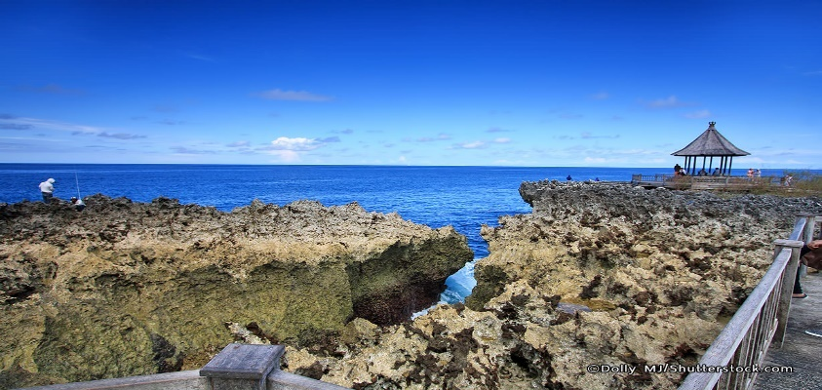 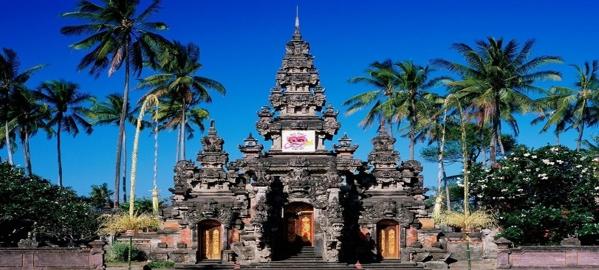

|  |  |
| --- | --- |
| **Day/**  **天数** | **Fun Itinerary / 行程 TOUR CODE : I-4DPS** |
| **1** | **Kuala Lumpur - Bali – Water Blow (D)**  Upon arrive Bali International airport, meet with local guide and transfer to visit **Tanah Lot Temple,** built by one of the last priests to come to Bali from Java in the 16th century, its rituals the paying of homage to the guardian spirits of the sea. Tanah Lot Temple the temple on the hugo rock facing indian ocean with amazing sunset.  **吉隆坡 - 巴厘 - 努沙杜瓦水冲 （晚餐）**  抵达机场后，由专业导游迎接前往**海神庙，**盖在海边的一块巨岩上，它是巴厘岛最著名的寺庙之一。 |
| **2** | **Ubud (B/L/D)**  After breakfast proceed to ubud **Bali Culture Center** is describe about the whole Bali with detail that involves many kind of Balinese cultures, Balinese dances, Balinese handicrafts and also about the Balinese life activities, here can enjoy the **balinese performance** dance and activity. After continues to ubud **art market** for shopping art market like silver, batik, handicraf. **UBUD PALACE** is a ubud kingdom palace with a beautiful traditional house as a residence of ubud king.  **乌布 （早/午/晚餐）**  早餐后，前往**巴厘文化中心**，各种手工艺品，工艺品，美术雕刻，木刻，石刻，油画，美术创作。超级有文化氛围，在这里还可欣赏到**巴厘村民的精彩表演**。接着前往**艺术市场**，乌布市集的大多数商品均在附近的村庄里进行制作，是购买巴厘岛手工艺品和纪念品的不二选择。接着前往**乌布皇宫**，16世纪时乌布王朝聘请著名艺术家规划设计而成，华丽的巴厘岛特有建筑风格值得一游，还可以感受巴厘岛王室当时生活。 |
| **3** | **Magrove Jungle Explore (B/L/D)**  After breakfast, visit to **explore mangrove**, use the traditional boat (in indonesia languages Jukung) from one of local fisherman harbour to mangrove area for about ± 1 - 2 hours. It will show you More than 10 species of mangrove trees can be found. after that will to **Braja shandi monument:** is monument of Balinese People Struggle, is recognized by the name of Bajra Sandhi because it's form is looking like Bajra or Genta or bell used by all Hindu Priest in reading off Weda holy sentence (mantra) at religious ceremony. Next to **Uluwatu temple** the mysteriaus holly ancient temple, located of 250 feet above sea level on the southern point of pura luhur.  **红树林**  **（早/午/晚餐）**  早餐后，将开始探索**红树林**，将会乘搭传统的船，从当地渔夫港口到红树林地区约±1 - 2小时，超过10种红树林可以找到。之后将到**Braja shandi纪念碑**：是巴厘岛人民斗争的纪念碑，它的形式看起来像Bajra或Genta或所有印度教牧师在阅读Weda圣句（佛经）在宗教仪式上使用的铃铛。接着参观**Uluwatu寺庙**mysteriaus霍莉古庙这个寺庙位于在海平面上的250英尺水平在pura luhur南部的点的。 |
| **4** | **Bali – Kuala Lumpur** **(B)**  After breakfast, free at own leisure till transfer to airport for departure with a sweet memories.  **巴厘 – 吉隆坡**  **(早餐)**  早餐后, 自由活动至送往机场启程回国, 结束4天愉快旅程。 |

|  |  |  |  |  |  |  |  |  |  |  |
| --- | --- | --- | --- | --- | --- | --- | --- | --- | --- | --- |
| **TRAVELING PERIODE: Now - 31 MAR 2018**  **TOUR CODE : I-4DPS** | | | | **4D BALI FULL(BOARD**  **(Per pax) (RM)** | | | | **Extension Night (RM) PER ROOM/NIGHT** | | **Remark** |
| **Class** | **Area** | **Hotel** | **Category** | **Twin/ Triple** | **Single Sup** | **Cwb** | **Cnb** | **Twin /**  **Single** | **Triple** | **Surcharge RM (Per Room Per Night)** |
| **3\*** | legian | neo patih jelantik | Standard | **610** | **770** | **480** | **340** | **150** | **190** | 20 DEC - 05 JAN 2018 : RM 70/R/N  13 FEB – 20 FEB 2018 :  RM 65/R/N |
| legian | [harmony legian](http://www.http/pophotels.com/) | Superior | **610** | **770** | **480** | **340** | **150** | **190** | 20 DEC - 05 JAN 2018 : RM 70/R/N  13 FEB – 20 FEB 2018 :  RM 65/R/N |
| legian | maxi hotel legian | Deluxe | **610** | **770** | **480** | **340** | **150** | **190** | 20 DEC - 05 JAN 2018 : RM 70/R/N  13 FEB – 20 FEB 2018 :  RM 65/R/N |
| kuta | Alea seminyak | Superior | **610** | **770** | **480** | **340** | **150** | **190** | 20 DEC - 05 JAN 2018 : RM 70/R/N  13 FEB – 20 FEB 2018 :  RM 65/R/N |
| sunset | zia hotel ( ex holiday in express kuta) | Superior | **650** | **840** | **500** | **360** | **180** | **210** | 20 DEC - 05 JAN 2018 : RM 70/R/N  13 FEB – 20 FEB 2018 :  RM 65/R/N |
| **4\*** | sunset | B hotel | Superior | **670** | **880** | **520** | **370** | **190** | **230** | 20 DEC - 05 JAN 2018 : RM 70/R/N  13 FEB – 20 FEB 2018 :  RM 65/R/N |
| kuta | love fashion legian | Superior | **690** | **910** | **530** | **370** | **200** | **250** | 20 DEC - 05 JAN 2018 : RM 70/R/N  13 FEB – 20 FEB 2018 :  RM 65/R/N |
| legian | park regis kuta | Superior | **670** | **880** | **520** | **370** | **190** | **240** | 20 DEC - 05 JAN 2018 : RM 70/R/N  13 FEB – 20 FEB 2018 :  RM 65/R/N |
| kuta | best western resort kuta | Superior | **660** | **860** | **510** | **360** | **180** | **240** | 20 DEC - 05 JAN 2018 : RM 70/R/N  13 FEB – 20 FEB 2018 :  RM 65/R/N |
| kuta | [best western kuta villa](http://www.astoninntuban.com/) | Standard | **660** | **860** | **510** | **360** | **180** | **240** | 20 DEC - 05 JAN 2018 : RM 70/R/N  13 FEB – 20 FEB 2018 :  RM 65/R/N |
| kuta | swiss bell tuban | Standard | **690** | **920** | **530** | **370** | **200** | **260** | 20 DEC - 05 JAN 2018 : RM 70/R/N  13 FEB – 20 FEB 2018 :  RM 65/R/N |
| kuta | harris kuta galeria | belly glee | **670** | **880** | **520** | **370** | **190** | **240** | 20 DEC - 05 JAN 2018 : RM 70/R/N  13 FEB – 20 FEB 2018 :  RM 65/R/N |
| kuta | harris river view | harris | **660** | **860** | **510** | **360** | **180** | **240** | 20 DEC - 05 JAN 2018 : RM 70/R/N  13 FEB – 20 FEB 2018 :  RM 65/R/N |
| kuta | eden hotel | harris | **690** | **920** | **530** | **370** | **200** | **260** | 20 DEC - 05 JAN 2018 : RM 70/R/N  13 FEB – 20 FEB 2018 :  RM 65/R/N |
| kuta | royal singosari kuta ( ex royal eighteen) | eden | **740** | **1020** | **570** | **400** | **240** | **310** | 20 DEC - 05 JAN 2018 : RM 70/R/N  13 FEB – 20 FEB 2018 :  RM 65/R/N |
| ubud | [evitel ubud](http://www.jboutiquehotel.com/) | Superior | **790** | **1120** | **610** | **430** | **270** | **350** | 20 DEC - 05 JAN 2018 : RM 70/R/N  13 FEB – 20 FEB 2018 :  RM 65/R/N |
| seminyak | maison atc seminyak | Superior | **740** | **1020** | **570** | **400** | **240** | **290** | 20 DEC - 05 JAN 2018 : RM 120/R/N  13 FEB – 20 FEB 2018 :  RM 65/R/N |
| kuta | bali rani hotel | Superior | **840** | **1220** | **650** | **450** | **300** | **380** | 20 DEC - 05 JAN 2018 : RM 120/R/N  13 FEB – 20 FEB 2018 :  RM 80/R/N |
| kuta | ramayana hotel | Deluxe | **870** | **1280** | **670** | **460** | **320** | **420** | 20 DEC - 05 JAN 2018 : RM 120/R/N  13 FEB – 20 FEB 2018 :  RM 80/R/N |
| legian | haper legian | Superior | **760** | **1070** | **590** | **410** | **250** | **330** | 20 DEC - 05 JAN 2018 : RM 120/R/N  13 FEB – 20 FEB 2018 :  RM 80/R/N |
| kuta | hard rock hotel | Deluxe | **1270** | **2080** | **970** | **670** | **590** | **800** | 20 DEC - 05 JAN 2018 : RM 271/R/N  13 FEB – 20 FEB 2018 :  RM 100/R/N  Compulsory dinner tba, min stay 4 night new year |
| ubud | grand sunti ubud | Superior | **750** | **1050** | **580** | **410** | **250** | **320** | 20 DEC - 05 JAN 2018 : RM 120/R/N  13 FEB – 20 FEB 2018 :  RM 80/R/N |
| ubud | best western premier ubud | Deluxe | **940** | **1430** | **720** | **500** | **370** | **450** | 20 DEC - 05 JAN 2018 : RM 120/R/N  13 FEB – 20 FEB 2018 :  RM 80/R/N |
| **VILLA** | seminyak | amor bali villa | 1 bed pool villa | **1150** | **1830** | **870** | **600** | **510** | **580** | 20 DEC - 05 JAN 2018 : RM 120/R/N  13 FEB – 20 FEB 2018 :  RM 80/R/N |
| seminyak | uppala villa seminyak | 1bed pool villa | **890** | **1320** | **680** | **480** | **340** | **410** | 20 DEC - 05 JAN 2018 : RM 105/R/N  13 FEB – 20 FEB 2018 :  RM 69/R/N |
| **5\*** | kuta | bali dynasty | Deluxe | **1120** | **1780** | **860** | **590** | **490** | **680** | 20 DEC - 05 JAN 2018 : RM 271/R/N  13 FEB – 20 FEB 2018 :  RM 100/R/N  Compulsory dinner tba, min stay 3 night new year |
| kuta | pullman legian | Deluxe | **1380** | **2290** | **1050** | **720** | **660** | **850** | 20 DEC - 05 JAN 2018 : RM 271/R/N  13 FEB – 20 FEB 2018 :  RM 100/R/N  Compulsory dinner tba, min stay 4 night new year |

|  |
| --- |
| **Package Included :-** |
| * 03 Nights hotel accommodation with daily breakfast * Round trip Seat In Coach airport & sightseeing transfer * Sightseeing with tour guide & entrance fee as mentioned in program tour (based on seats in coach ) |
| **Term & Conditional :-** |
| * ***Surcharge***: An additional surcharge will be imposed for the following: * Compulsory tour guide & driver tipping for **English Guide** : **RM40.00** per person * Compulsory tour guide & driver tipping for **Mandarin Guide** : **RM60.00** per person * Any request for **private tour** additonal **RM 30**/pax /package |
| **Remark :-**   1. The tour is based on Sit-In-Coach 2. Minimum 02 paxs per booking. 3. FOC meal arrangement halal or Vegetarian. 4. General **travel period** : **Now** until **31 Mar 2018** ( Travel **date must completed by 31 Mar 2018**). 5. No refund for any unused portion of this package or during tour 6. Only for **Malaysian Market.** 7. The sequence of the itinerary and meals is subject to change without notice by the local ground agency 8. Any cancellation that made by clients for any unutilized services, unused tours or hotel rooms are non-refundable |

*Updated : 06 Nov 2017*