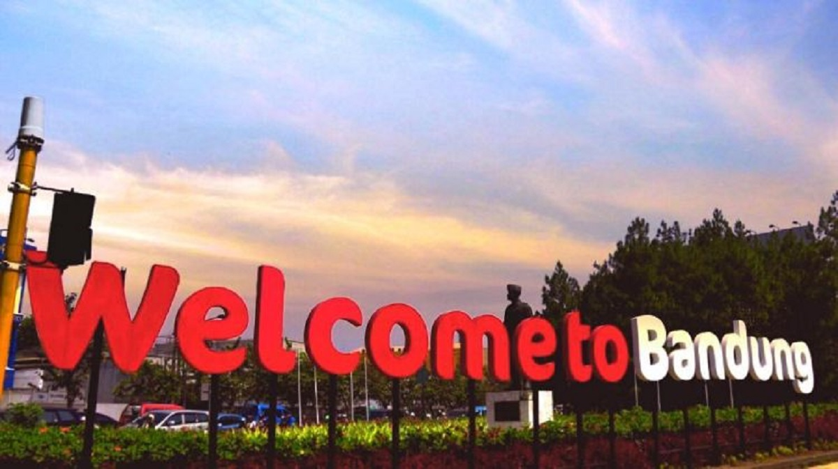

3D2N Bandung Free & Easy (GV-2)

3天2晚 万隆 自由行 (GV-2)

|  |  |
| --- | --- |
| **Day** | **Fun Itinerary / 行程 TOUR CODE : I-3BDO** |
| **1** | **Kuala Lumpur – Bandung**  Upon arrival at Bandung Airport. You will be meet up our representative and proceed to hotel check-in.  **吉隆坡 – 万隆**  到达万隆机场后,乘空调旅游巴士送往酒店登记。 |
| **2** | **Bandung (B)**  After breakfast, free & easy or join optional tour  **万隆 （早餐）**  早餐后, **自由活动或参与自费项目。** |
| **3** | **Bandung – Kuala Lumpur (B)**  After breakfast, you will be transferred to the airport for your next destination.  **万隆 – 吉隆坡 （早餐）**  早餐后，自由活动至送往送往机场启程回国, 结束愉快旅程。 |

|  |  |  |  |  |  |  |  |  |  |
| --- | --- | --- | --- | --- | --- | --- | --- | --- | --- |
| **TRAVELING PERIOD ON 01 APR 2019 – 31 OCT 2019** | | | | | | | | | |
| **Star** | **Hotel**  **TOUR CODE : I-3BDO** | **Price per person (RM)** | | | | **Extension Night**  **(Based** **on per pax per night)(RM)** | | | |
| **Twin** | **Single** | **CWB** | **CNB** | **Twin** | **Single** | **E.Bed** | **ABF** |
| **3\*** | Tebu / Pasar Baru Square or similar | **305** | **450** | **190** | **245** | **120** | **195** | **120** | **80** |
| **4\*** | Grand Tebu / Jayakarta or similar | **425** | **605** | **385** | **325** | **145** | **240** | **145** | **100** |
| **5\*** | Papandayan / Prama Preanger or similar | **465** | **700** | **415** | **360** | **180** | **290** | **180** | **120** |
| **BLOCK OUT DATE : 19 - 20 APR, 27 MAY – 10 JUN, 01 JUL – 31 AUG 2019** | | | | | | | | | |

|  |
| --- |
| **Package Included :-** |
| * **02 Nights** hotel accommodation with daily breakfast * Round trip **Private Coach** airport & sightseeing transfer * All meals as per itinerary (non halal or vegetarian) * Sightseeing with tour guide & entrance fee as mentioned in program tour (based on **Private coach** ) |

|  |
| --- |
| **Term & Conditional :-** |
| * ***Surcharge***: An additional surcharge will be imposed for the following: * Addition **RM150 per person** if flight **arrive & depart Jakarta Airport.** * **Infant (Below 24Months )** - Only pay for Tipping. |
| **Remark :-** |
| 1. Only Valid for **Malaysia Market**. 2. The tour is based on **Private Coach.** 3. Minimum 02paxs per booking. 4. High season and Long weekend will be surcharge (if applicable). 5. General **travel period** : **01 Apr 2019** until **31 Oct 2019** ( Travel **date must completed by 31 Oct 2019**) 6. No refund for any unused portion of this package or during tour 7. The sequence of the itinerary and meals is subject to change without notice by the local ground agency 8. Rate are based on compulsory shopping stop. 9. Any cancellation that made by clients for any unutilized services, unused tours or hotel rooms are non-refundable |