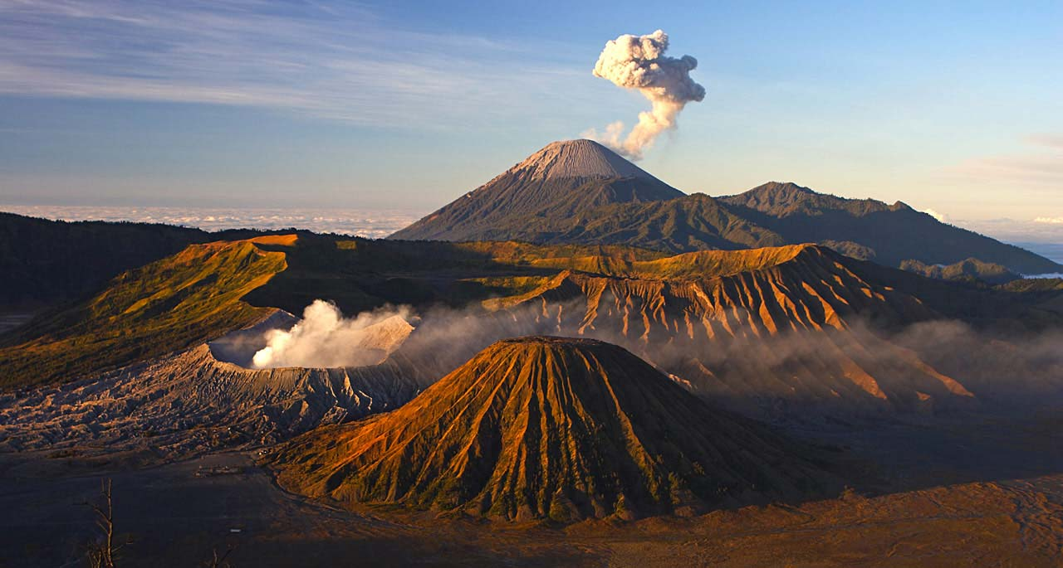

3D2N Surabaya Free & Easy

3天2晚 泗水 自由行

|  |  |
| --- | --- |
| **Day/天数** | **Fun Itinerary / 行程 TOUR CODE : SUB-3FE** |
| ***1*** | **Kuala Lumpur – Surabaya**  Upon arrival at Surabaya Airport. You will be meet up our representative and proceed to hotel check-in.  **吉隆坡 – 泗水**  到达万泗水场后,乘空调旅游巴士送往酒店登记。 |
| ***2*** | **Surabaya (B)**  After breakfast, free & easy or join optional tour.  **泗水 （早）**  早餐后, 自由活动或参与自费项目。 |
| ***3*** | **Surabaya – Kuala Lumpur (B)**  After breakfast, you will be transferred to the airport for your next destination.  **泗水 – 吉隆坡 （早）**  早餐后，自由活动至送往送往机场启程回国, 结束3天愉快旅程。 |

|  |  |
| --- | --- |
| **Optional Tour** (Minimum 02 Paxs based on **PRIVATE** arrangement) | **Rate based on per person (RM)** |
| Surabaya City Tour (3 Hours) | **RM 330** |
| Safari park & Tanggulangin Tour (8 Hours) | **RM 370** |
| Malang Tour (9 Hours) | **RM 370** |

|  |  |  |  |  |  |  |  |  |  |  |  |
| --- | --- | --- | --- | --- | --- | --- | --- | --- | --- | --- | --- |
| **CAT** | **Hotel**  **or similar class**  **TOUR CODE : SUB-3FE** | **Price Per Adult (RM)** | | | | | | **Extension Night +ABF**  **(Based on per pax per night)** | | | |
| **02-03** | **04-06** | **07-09** | **10-15** | **16 up** | **Single supp** | **Twin** | **Single** | **E.Bed** | **ABF** |
| **3\*** | **Max One Hotel Tidar** | 560 | 500 | 495 | 485 | 460 | 330 | 170 | 300 | 170 | 65 |
| **3\*** | **Swiss Belinn Tunjungan** | 605 | 540 | 535 | 530 | 500 | 375 | 190 | 340 | 190 | 80 |
| **4\*** | **Mercure Miramar** | 640 | 575 | 570 | 565 | 535 | 415 | 210 | 380 | 210 | 95 |
| **4*+** | **Four Point by Sheraton** | 715 | 650 | 645 | 640 | 610 | 485 | 245 | 450 | 245 | 105 |
| **5\*** | **Majapahit** | 835 | 775 | 765 | 760 | 730 | 600 | 305 | 570 | 305 | 115 |
| **5\*** | **JW Marriot** | 900 | 835 | 825 | 820 | 795 | 660 | 335 | 630 | 335 | 135 |
| **BLOCK OUT DATE : 01 – 10 JUN 2019** | | | | | | | | | | | |

|  |
| --- |
| **Package Included :-** |
| * **02 Nights** hotel accommodation with daily breakfast * Round trip **Private Coach** airport & sightseeing transfer * Sightseeing with tour guide & entrance fee as mentioned in program tour (based on **Private coach** ) |

|  |
| --- |
| **Term & Conditional :-** |
| * ***Surcharge***: An additional surcharge will be imposed for the following: * **Child Fare :** Child Half Twin 100% ;Child with Bed 85% ; Child without bed 65% of Tour Fare. * **Infant (Below 24Months )** - Only pay for Tipping. |
| **Remark :-** |
| 1. Minimum 02paxs per booking. Only Valid for **Malaysia Market**. The tour is based on **Private Coach.** 2. **High season and Long weekend will be surcharge (if applicable).** 3. General **travel period** : **01 APR 2019** until **31 OCT 2019**( Travel **date must completed by 31 OCT 2019**) 4. No refund for any unused portion of this package or during tour 5. The sequence of the itinerary and meals is subject to change without notice by the local ground agency 6. Rate are based on compulsory shopping stop. 7. Any cancellation that made by clients for any unutilized services, unused tours or hotel rooms are non-refundable |