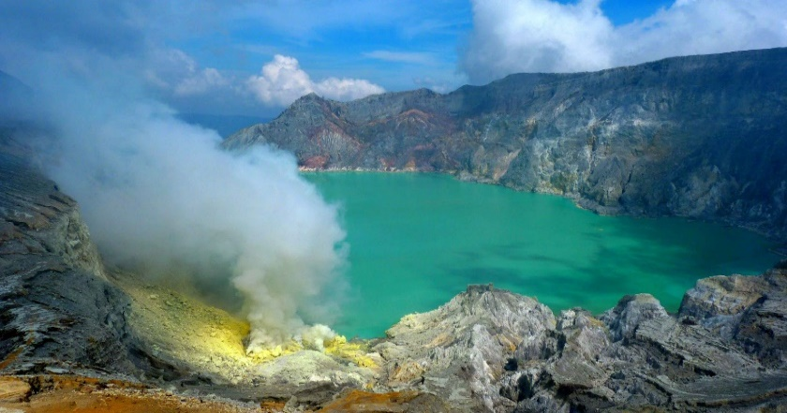

**4D3N Surabaya Fantastic**

**4天3晚 泗水**

|  |  |
| --- | --- |
| **Day/天数** | **Fun Itinerary / 行程 TOUR CODE : SUB-4FT** |
| ***1*** | **Kuala Lumpur – Surabaya – Mt Bromo (L/D)**  Arrive at Surabaya International Airport. Meet & greet with our tour guide, proceed to **Cemorolawang/Tosari Village** at Bromo area & Overnight.  **Weekend surcharge at Mt. Bromo RM 50/pax (Saturday & Sunday)  **吉隆坡 – 泗水 – Bromo火山 （午/晚餐）**  抵达泗水机场后，由专业导游迎接您及前往位于**Bromo火山**的【**Cemorolawang/Tosari 村**】。过后前往入住酒店。  **周末附加费用 Mt. Bromo RM 50/人（星期六 & 星期日） |
| ***2*** | **Sunrise Mt.Bromo – Ijen Crater (B/L/D)**  At 3.30 in the early morning you will be wake up & start **Mt. Bromo tour,** to witness sunrise from rim of crater. The tour will conducted by **pony riding** (own expenses) cross sea of sand and climb up 245 stairs. After enjoy the **surrounding of Mt. Bromo**, back to hotel for breakfast and repacking. Then transfer to **Jajag Village** about 4 hours drive en route drop by **Jember city tour** **for becak ride**. Overnight at Jajag Village  **Bromo火山日出 – Ijen火山 （早/午/晚餐）**  清晨3:30准时出发前往Bromo火山之旅。首先徒步抵达【**Bromo火山边缘欣赏日出**】，然后经过浩瀚的【**沙洲**】（骑小马自费）再攀爬245梯阶然后沉溺在Bromo火山的怀抱与壮丽的景色。之后，返回酒店享用早餐与收拾行李。之后，经过4小时车程将抵达【**Jajag 村**】。途经【**Jember市**】**乘坐三轮车游览市区**。 |
| ***3*** | **Ijen Trekking - Surabaya (B/L/D)**  Early morning proceed to **Paltuding** ranger post and start the Ijen trekking about 3 km (90 minutes). On the way to the rim, will be meet a sulphur miners which is the local miners to carry a sulphur by bamboo basket on his shoulder. After take some photo and get enjoy panorama, back to the post and next transfer to **Surabaya** en route drop by **Papuma Beach.** Overnight at Surabaya City.  **Ijen火山徒步之旅 - 泗水 （早/午/晚餐）**  早餐后，前往【**Ijen火山**】徒步约3公里（90分钟）。途中还能看见当地的硫磺矿工用竹蓝运送硫磺。拍照留念之后，将前往**泗水**。途经【**Papuna海滩**】。过后前往入住泗水酒店 |
| ***4*** | **Surabaya – Kuala Lumpur (B)**  After breakfast, you will be transferred to the airport for your next destination.  **泗水 – 吉隆坡 （早）**  早餐后，自由活动至送往送往机场启程回国, 结束4天愉快旅程。 |

|  |  |  |  |  |  |  |  |  |
| --- | --- | --- | --- | --- | --- | --- | --- | --- |
| **CAT** | **HOTEL**  **TOUR CODE : SUB-4FT** | **Travel Date** | **Price per Adult per package (RM)** | | | | | |
| **02 - 03** | **04 - 06** | **07 - 09** | **10 - 15** | **16 up** | **Single Supp** |
| **3\***  **2\***  **3\*** | **Surabaya :** Max One Hotel Tidar or sml  **Mt Bromo :** Nadia or sml  **Ijen :** Ketapang Indah or sml | **01 APR –**  **31 OCT 2019** | **2180** | **1590** | **1510** | **1450** | **1310** | **445** |
| **3\***  **2\***  **3\*** | **Surabaya :** Swiss Belinn Tunjungan or sml  **Mt Bromo :** Lava View or sml  **Ijen** : Ketapang Indah or sml | **2230** | **1640** | **1560** | **1500** | **1360** | **495** |
| **4*+**  **2\***  **3\*** | **Surabaya :** Four Point by Sheraton or sml  **Mt Bromo :** Lava View or sml  **Ijen** : Ketapang Indah or sml | **2300** | **1710** | **1630** | **1565** | **1430** | **565** |
| **BLOCK OUT DATE : 01 – 10 JUN 2019** | | | | | | | | |

|  |
| --- |
| **Package Included :-** |
| * **03 Nights** hotel accommodation with daily breakfast * Round trip **Private Coach** airport & sightseeing transfer * All meals as mentioned in itinerary (halal or vegetarian). * Escorted orientation tour by **English Speaking Guide.** * Sightseeing with tour guide & entrance fee as mentioned in program tour (based on **Private coach** ) |

|  |
| --- |
| **Term & Conditional :-** |
| * ***Surcharge***: An additional surcharge will be imposed for the following: * **Mandarin speaking guide Fee** (subjected to availability with surcharge) : RM120 per guide per day. Tipping RM45 per person * **Child Fare :** Child Half Twin 100% ;Child with Bed 85% ; Child without bed 65% of Tour Fare. * **Infant (Below 24Months )** - Only pay for Tipping. |
| **Remark :-** |
| 1. **Compulsory Tipping RM 40 per person**. 2. Only Valid for **Malaysia Market**. 3. The tour is based on **Private Coach.** 4. Minimum 02paxs per booking. 5. **High season and Long weekend will be surcharge (if applicable).** 6. General **travel period** : **01 Apr 2019** until **31 Oct 2019**( Travel **date must completed by 31 Oct 2019**) 7. No refund for any unused portion of this package or during tour 8. The sequence of the itinerary and meals is subject to change without notice by the local ground agency 9. Rate are based on compulsory shopping stop. 10. Any cancellation that made by clients for any unutilized services, unused tours or hotel rooms are non-refundable |