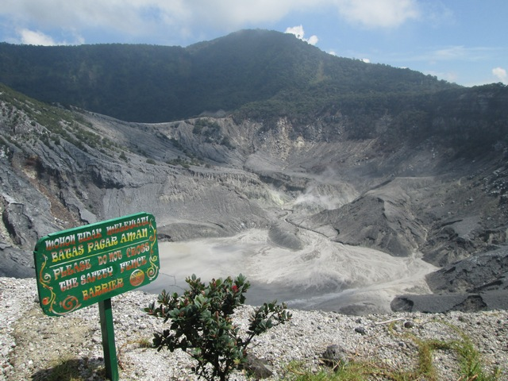

3D2N Bandung Full Board (GV2)

3天2晚 万隆（GV2）

|  |  |
| --- | --- |
| **Day** | **Fun Itinerary / 行程 TOUR CODE : I-3BFL** |
| **1** | **Kuala Lumpur – Bandung (D)**  Upon arrival at Bandung Airport, you will be meet up our representative and proceed for Bandung city tour, visiting many historical sites such as: **ITB, Satay House Building, Asia Africa Conference Building** (Gedung Merdeka) and **Dutch Colonial** residence areas. After that, check in hotel after dinner.  **吉隆坡 – 万隆 （晚餐）**  到达万隆机场后, 由专业导游迎接您及前往万隆市区观光。参观许多历史遗迹，例如：【**ITB**】，【**Satay House Building**】, 【**亞非會議博物館**】，【**荷兰殖民居住地**】等等。晚餐后前往入住酒店。 |
| **2** | **Bandung (B/L/D)**  Breakfast at hotel. Proceed to **White Crater** **Volcano** where you can enjoy crater in Indonesia. After that transfer to **Ranca Upas Hot Spring Water** and **Ciwidey Strawberry Farm**. Lunch at Indonesian food restaurant. Afterwards back to Bandung city and transfer to **Cihampelas jeans Street** for shopping program at Factory outlets. Dinner at local restaurant, back to hotel and **free program**.  **万隆 （早/午/晚餐）**  早餐后，前往【**白色火山湖**】，【**Ranca Upas温泉区**】享受温泉。过后前往【**草莓园**】。午餐后， 继续前往【**万隆市进行购物**】。晚餐后，送往酒店休息。 |
| **3** | **Bandung – Kuala Lumpur (B)**  After breakfast, you will be transferred to the airport for your next destination.  **万隆 – 吉隆坡 （早餐）**  早餐后，自由活动至送往送往机场启程回国, 结束3天愉快旅程。 |

|  |  |  |  |  |  |  |
| --- | --- | --- | --- | --- | --- | --- |
| **TRAVELING PERIOD ON 01 APR 2019 – 31 OCT 2019** | | | | | | |
| **Star** | **Hotel**  **TOUR CODE : I-3BFL** | **Price per Adult per package (RM)** | | | | |
| **02 - 03** | **04 - 06** | **07 - 15** | **16 up** | **Single supp** |
| **3\*** | Tebu / Pasar Baru Square or similar | **825** | **675** | **585** | **565** | **255** |
| **4\*** | Grand Tebu / Jayakarta or similar | **880** | **730** | **650** | **625** | **300** |
| **5\*** | Papandayan/ Prama Preanger or similar | **930** | **780** | **695** | **675** | **360** |
| **BLOCK OUT DATE : 19 – 20 APR, 27 MAY – 10 JUN, 01 JUL – 31 AUG 2019** | | | | | | |

|  |
| --- |
| **Package Included :-** |
| * **02 Nights** hotel accommodation with daily breakfast * Round trip **Private Coach** airport & sightseeing transfer * All meals as per itinerary (non halal or vegetarian) * Escorted orientation tour by **English** Speaking Guide * Sightseeing with tour guide & entrance fee as mentioned in program tour (based on **Private coach** ) |
| **Term & Conditional :-** |
| * ***Surcharge***: An additional surcharge will be imposed for the following: * Addition **RM150 per person** if flight **arrive & depart Jakarta Airport.** * **Child Fare (under 10 year old):** Child Half Twin 100% ;Child with Bed 85% ; Child without bed 65% of Tour Fare. * **Infant (Below 24Months )** - Only pay for Tipping. |
| **Remark :-** |
| 1. **Compulsory Tipping RM 30 per person**. 2. Minimum 02paxs per booking. Only Valid for **Malaysia Market**. The tour is based on **Private Coach.** 3. High season and Long weekend will be surcharge (if applicable). 4. General **travel period** : **01 Apr 2019** until **31 Oct 2019** ( Travel **date must completed by 31 Oct 2019**) 5. No refund for any unused portion of this package or during tour 6. The sequence of the itinerary and meals is subject to change without notice by the local ground agency 7. Rate are based on compulsory shopping stop. 8. Any cancellation that made by clients for any unutilized services, unused tours or hotel rooms are non-refundable |