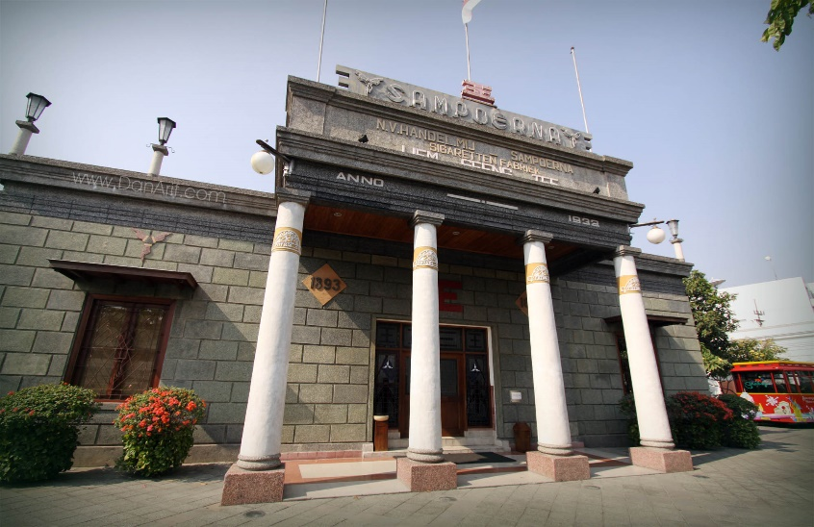

**3D2N Surabaya Full Board**

**3天2晚 泗水**

|  |  |
| --- | --- |
| **Day/天数** | **Fun Itinerary / 行程 TOUR CODE : SUB-3FB** |
| ***1*** | **Kuala Lumpur – Surabaya (L/D)**  Upon arrive at Surabaya International Airport. Meet & greet with our tour guide, Surabaya city tour visit to **House of Sampoerna** (cigarette museum and see how to make a cigarette manually by hand rolling during on weekdays starting 0700-1200), Next visit to **Sunan Ampel Mosque, Arab Quarter,** **Passing Kembang Jepun Chinese Town** and **Cheng Ho Chinese Mosque**. Then transfer for check in hotel  **吉隆坡 – 泗水 （午/晚餐）**  抵达泗水机场后，由专业导游迎接您及前往泗水市区观光【**三宝麟之屋**】（这里就是过去生产著名丁香烟的工厂旧址，平日在这里还可以观赏手工制作香烟的过程）接着参观【**苏南安佩尔回教堂**】和【**阿拉伯部落**】然后途经泗水19世纪的城市中心【**Kembang Japun 唐人区**】和【**郑和清真寺**】。过后前往入住酒店。 |
| ***2*** | **Surabaya (B/L/D)**  Breakfast at hotel, proceed visit to **Tanggulangin** as leather home industry, **Sidoarjo** is known as for shrimp crackers & Batik. Continued **shopping at PGS** (Pusat grosir Surabaya), **ITC Mega Grosir** and **Mirota Art Shop.**  **泗水 （早/午/晚餐）**  早餐后，前往【**Tanggulangin 皮革中心**】，【**Sidoarjo虾饼制造**】和【**芭迪制作坊**】。之后继续【**购物于PGS**】,【**ITC Mega Grosir**】和【**Mirota 艺术坊**】。晚餐后，送往酒店休息。 |
| ***3*** | **Surabaya – Kuala Lumpur (B)**  After breakfast, you will be transferred to the airport for your next destination.  **泗水 – 吉隆坡 （早）**  早餐后，自由活动至送往送往机场启程回国, 结束3天愉快旅程。 |

|  |  |  |  |  |  |  |  |  |  |  |  |
| --- | --- | --- | --- | --- | --- | --- | --- | --- | --- | --- | --- |
| **CAT** | **Hotel**  **or similar class**  **TOUR CODE : SUB-3FB** | **Price Per Adult (RM)** | | | | | | **Extension Night +ABF**  **(Based on per pax per night)** | | | |
| **02-03** | **04-06** | **07-09** | **10-15** | **16 up** | **Single supp** | **Twin** | **Single** | **E.Bed** | **ABF** |
| **3\*** | **Max One Hotel Tidar** | 1180 | 870 | 810 | 785 | 690 | 330 | 170 | 300 | 170 | 65 |
| **3\*** | **Swiss Belinn Tunjungan** | 1220 | 910 | 845 | 825 | 730 | 365 | 190 | 340 | 190 | 80 |
| **4\*** | **Mercure Miramar** | 1255 | 955 | 895 | 870 | 780 | 405 | 210 | 380 | 210 | 95 |
| **4*+** | **Four Point by Sheraton** | 1335 | 1025 | 960 | 935 | 845 | 480 | 245 | 450 | 245 | 105 |
| **5\*** | **Majapahit** | 1465 | 1155 | 1100 | 1070 | 980 | 600 | 305 | 570 | 305 | 115 |
| **5\*** | **JW Marriot** | 1535 | 1215 | 1155 | 1130 | 1035 | 660 | 335 | 630 | 335 | 135 |
| **BLOCK OUT DATE : 01 – 10 JUN 2019** | | | | | | | | | | | |

|  |
| --- |
| **Package Included :-** |
| * **02 Nights** hotel accommodation with daily breakfast * Round trip **Private Coach** airport & sightseeing transfer * All meals as mentioned in itinerary (halal or vegetarian). * Escorted orientation tour by **English Speaking Guide.** * Sightseeing with tour guide & entrance fee as mentioned in program tour (based on **Private coach** ) |

|  |
| --- |
| **Term & Conditional :-** |
| * ***Surcharge***: An additional surcharge will be imposed for the following: * **Mandarin speaking Guide Fee** (subjected to availability with surcharge) : RM 120 per guide per day. Tipping RM 45 per pax * **Child Fare :** Child Half Twin 100% ;Child with Bed 85% ; Child without bed 65% of Tour Fare. * **Infant (Below 24Months )** - Only pay for Tipping. |
| **Remark :-** |
| 1. **Compulsory Tipping RM 30 per person**. 2. Only Valid for **Malaysia Market**. 3. The tour is based on **Private Coach.** 4. Minimum 02paxs per booking. 5. **High season and Long weekend will be surcharge (if applicable).** 6. General **travel period** : **01 Apr 2019** until **31 Oct 2019**( Travel **date must completed by 31 Oct 2019**) 7. No refund for any unused portion of this package or during tour 8. The sequence of the itinerary and meals is subject to change without notice by the local ground agency 9. Rate are based on compulsory shopping stop. 10. Any cancellation that made by clients for any unutilized services, unused tours or hotel rooms are non-refundable |