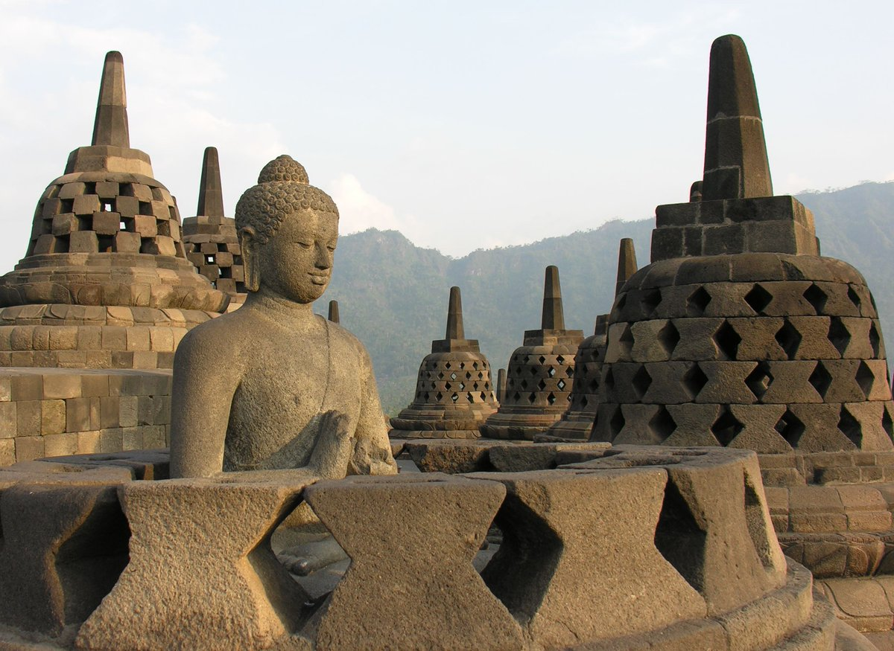

**4D3N Explorer Borobudur**

**4天3晚 日惹~婆罗浮屠**

|  |  |
| --- | --- |
| **Day** | **Fun Itinerary / 行程 TOUR CODE : YOG-4BRB** |
| ***1*** | **Kuala Lumpur – Jogjakarta – Hutan Pinus - Breksi Cliff (L/D)**  Meet and greet with our guide at Yogyakarta airport, After lunch, visit **Imogiri Pine Forest** (Hutan Pinus Mangunan) offers exotic beauty of hundreds of towering pine tree. This forest will become famous reddish brown color of the soil, the air is fresh, cool wind, and the sun peeking in between tree clawing the sky. Renowned for its romantic scenery, the forest became one spot of interest as a place to take pictures. Continue to **Breksi Cliff** is formed by the rock mining activity by the local people. In the hands of the local artists, the 20 meters abandoned limestone cliff mining turned into tremendous spot to enjoy art performance, and sunset. Afterward continue to **Malioboro Shopping centre**. Lunch and Dinner at local restaurant. Check in Hotel. After dinner, check-in Hotel.  **吉隆坡 – 日惹 – Imogiri森林 - 悬崖公园 （午/晚餐）**  抵达日惹国际机场后,由专业导游迎接送往餐厅享用午餐。 午餐后前往【**Imogiri森林**】這裡有美丽的風景和宁静的气氛。在美丽地種下松樹之前，這個500公頃的地区曾經是一片空地。附近的其他景點包括天然泉水和水果花园。您可边尝试找到最佳的拍照角度。随后续往【**Breksi悬崖公园**】主要风景是高耸的一排砾岩岩崖.这个悬崖已经是数百年前形成的，石灰岩得采矿活动将其变成了独特的悬崖景点。购物于【**Malioboro街**】。晚餐后送往酒店登记入住。 |
| ***2*** | **Borobudur – Lava Tour (B/L/D)**  After breakfast, pick up from at your hotel and proceed to **Cangkringan – a village** in the slope of Mt Merapi that is totally destroyed after the last great eruption of Merapi in November 4th and 5th, 2010. The hot cloud (pyroclastic flow) hit this village. Including visit the **Museum Gunung Merapi or Merapi Volcano Museum** which was built by supporting cost of the Department of Energy, Mining and Natural Resources and opened at October 1st, 2009. Afterward visit **Borobudur Temple** and **Mendut & Pawon temples.** Back to **Yogyakarta city** on the way can stop buy sweet Salak Pondoh known as snake fruit, Lunch and dinner at local restaurant.  (Optional : 4 Wheel Jeep to Mount Merapi RM 120 per jeep , max 4 pax per jeep )  **婆罗浮屠 – Lava火山 （早/午/晚餐）**  早餐后,前往【**Cangkrigan村庄**】2010年11月4-5日把这个村庄完全摧毁。然后继续参观【**Merapi火山博物馆**】午餐后，前往【**婆罗浮屠塔**】位于印度尼西亚中爪哇日惹市西北约40公里处墨拉比火山的一个山丘上，以精美的浮雕闻名于世。继续参观【**Mendut寺**】位于向东3公里从【**婆罗浮屠寺**】和【**Pawan寺**】在返回市区的路途中，可以购买蛇果。晚餐后，入住酒店。  (Optional : 4 Wheel Jeep to Mount Merapi RM 120 per jeep , max 4 pax per jeep ) |
| ***3*** | **Kasongan / Sunset Parangtritis (B/L/D)**  After breakfast, transfer to visit **Kraton Sultan’s Palace**. We continue the tour to **Taman Sari Water Castle**, continue to **traditional Batik Home industry.** Then visit **Kotagede Village** to see a hundred-year old tradition still being practiced by silver craftsmen. After Lunch, shopping at **Beringharjo traditional market** & along the way to **Malioboro street.** These area offer merchandise, batik, traditional snacks, Javanese herbs, rattan ornament and handicraft. Continue to **Kasongan Village** is known for the traditional clay potteries. At last sunset at **Parangtritis Beach.** Dinner at local restaurant.  **卡索根村/ 日落Parangtritis 海**  **（早/午/晚餐）**  早餐后, 开始游览【**苏丹宫殿**】继续参观【**日惹水晶宫**】地处建于一七五五年，是印尼伊斯兰教苏丹的故宫. 前往参观【**巴迪制造工厂蜡染布制造过程**】和【**庫塔歌德村**】一个拥有百年历史的村尚保存传统的银器制作。接着前去【**Malioboro街**】购物。接着前往【**Kasongan 村**】您可看到这里有许多工匠师傅亲手做的艺术品，如：花瓶，扑满，动物形象等。接着前往【**Parangtritis 沙滩**】观赏浪漫的日落。晚餐于当地餐厅 |
| ***4*** | **Jogjakarta – Kuala Lumpur (B)**  After breakfast, you will be transferred to the airport for your next destination.  **日惹 – 吉隆坡 （早）**  早餐后，自由活动至送往送往机场启程回国, 结束4天愉快旅程。 |

|  |  |  |  |  |  |  |  |  |  |  |  |
| --- | --- | --- | --- | --- | --- | --- | --- | --- | --- | --- | --- |
| **Star** | **Hotel**  **TOUR CODE : YOG-4BRB** | **.**  **VALIDITY : 01 APR 2019 – 31 OCT 2019** | | | | | | | | | |
| **Price per adult per package (RM)** | | | | | | **Extension Night**  **(Based** **on per pax per night)(RM)** | | | |
| **02-03** | **04-06** | **07-10** | **11-15** | **16 up** | **Single supp** | **Twin** | **Single** | **E.Bed** | **ABF** |
| **3\*** | **Pesonna Tugu** or sml | 1330 | 1170 | 1090 | 1030 | 1020 | 385 | 150 | 260 | 135 | 65 |
| **4\*** | **The Rich** or sml | 1405 | 1235 | 1160 | 1105 | 1100 | 445 | 170 | 300 | 150 | 85 |
| **5\*** | **Eastparc** or sml | 1515 | 1350 | 1275 | 1225 | 1215 | 565 | 215 | 390 | 195 | 100 |
| **5\*** | **Royal Ambarrukmo** or sml | 1605 | 1445 | 1360 | 1315 | 1300 | 650 | 240 | 440 | 220 | 100 |
| **BLOCK OUT DATE : 19 – 21 APR, 26 MAY – 09 JUN 2019** | | | | | | | | | | | |

|  |
| --- |
| **Package Included :-** |
| * **03 Nights** hotel accommodation with daily breakfast * Round trip **Private Coach** airport & sightseeing transfer * All meals as mentioned in itinerary (non halal or vegetarian). * Escorted orientation tour by **English Speaking Guide.** * Sightseeing with tour guide & entrance fee as mentioned in program tour (based on **Private coach** ) |

|  |
| --- |
| **Term & Conditional :-** |
| * ***Surcharge***: An additional surcharge will be imposed for the following: * **Child Fare :** Child Half Twin 100% ;Child with Bed 85% ; Child without bed 65% of Tour Fare. * **Infant (Below 24Months )** - Only pay for Tipping. |
| **Remark :-** |
| 1. **Compulsory Tipping RM 40 per person**. 2. Only Valid for **Malaysia Market**. 3. The tour is based on **Private Coach.** 4. Minimum 02paxs per booking. 5. **Mandarin speaking guide** subjected to availability with surcharge RM100/guide/day. Tipping RM40 per person 6. For flight arrival later than **1500 hours on Day 01**, **Prambanan Temple Tour + Lunch will arrange on last day** before airport transfer out with condition **airport transfer out time not earlier than 2 pm**, otherwise will be refund RM 60 per pax 7. General **travel period** : **01 APR 2019** until **31 OCT 2019** ( Travel **date must completed by 31 OCT 2019**) 8. No refund for any unused portion of this package or during tour 9. The sequence of the itinerary and meals is subject to change without notice by the local ground agency 10. Rate are based on compulsory shopping stop. 11. Any cancellation that made by clients for any unutilized services, unused tours or hotel rooms are non-refundable |