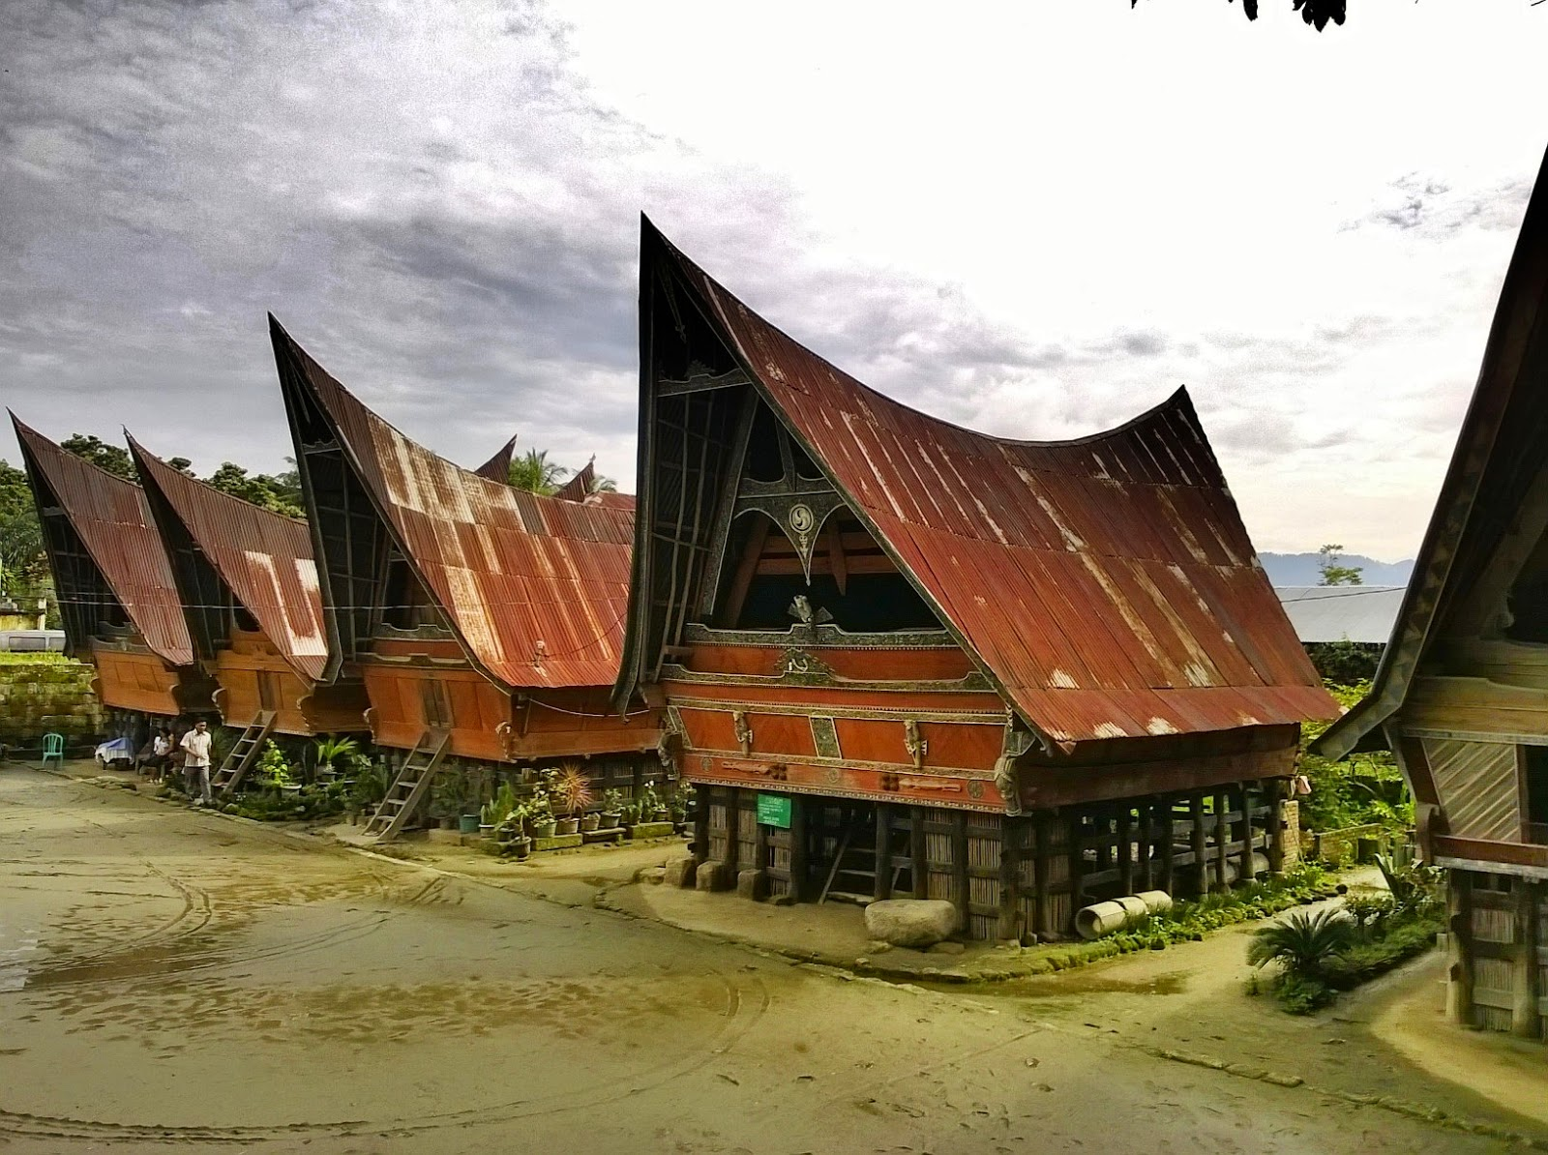

3D2N Wonderful Medan (GV2

3天2晚 棉兰 (GV2)

|  |  |
| --- | --- |
| **Day** | **Fun Itinerary / 行程 TOUR CODE: I-3DMD** |
| ***1*** | **Kuala Lumpur – Medan - Paparat (L/D)**  Arrival at Medan Airport, transfer to local restaurant for lunch. Continue the journey to **Parapat**, drive along the beautiful road which offers the endless view of rubber, palm oil, cocoa plantations and paddy fields. Stop at **Pematang Siantar** to buy some local snacks: ting, teng, kerupuk etc. Arrival in Parapat. Check in to hotel and dinner in Parapat. Evening **walk and shopping in Parapat**. Overnight at Samosir Island  **吉隆坡 – 棉兰 – 巴拉拨 （午/晚餐）**  抵达棉兰机场由专业导游接机后，前往享用午餐。续前往【**巴拉拔】**途中可见一望无际的的油棕园，橡胶园和可可园。途中【**先达镇**】短暂逗留，品尝当地极具盛名的花生甜品及土產。晚餐於酒店或当地餐厅，入住巴拉拔酒店。 |
| ***2*** | **Parapat – Samosir Island – Brastagi (B/L/D)**  After breakfast, **Samosir island tour** by boat : visit **Tomok Kampung** to see the Batak King‘s tombs (Raja Sidabutar) and **Ambarita Kampung** to see the traditional Batak village with the stone court and the execution place (Raja Sialagan) ( only for group minimum 10persons ) . Next to **Brastagi**, a mountain resort with its refreshing weather and magnificent scenery which has an abundance of flowers, vegetables and fruits. Visit **Simarjarunjung** the highest point by **Lake Toba**, the ancient **King’s Palace of Batak Simalungun** (Rumah Bolon) and **Sipiso-Piso waterfall**. In Brastagi visit **Gundaling Hill** to see the two active volcanoes in Brastagi: **Mount Sibayak** (2.172 m) and **Mount. Sinabung** (2.417 m) and **Pasar Buah** (Fruit Market). Check in to the hotel and dinner in Brastagi .Overnight at Brastagi.  **巴拉拔 - 沙摩西岛 - 达伯拉斯塔基 (早/午/晚餐)**  早餐后，乘船约 45 分钟船前往**多巴湖的沙摩西岛**参观【**多莫村**】看到西拉武达国王之陵墓，继续前往【**原住民安峇里达乡村**】在此可见到马达土族长老会议场所的石椅及保佑著国王的石棺，安巴里达国王的长屋及用於族長会议的石椅、行刑用的石桌(至少 10 个人）。接着前往**达伯拉斯塔基**停在优美的【**丝比索瀑布**】和【**西马仑根王长屋**】。过后到达伯拉斯塔基，您可以清楚远眺形势壮丽的【**席巴雅克】**和【**席纳彭火山】,【水果市場**】，琳瑯滿目的熱帶水果，如山竺、紅毛丹、蛇皮果，您可自由选购一些物美廉价各式熱帶水果品尝一番。入住达伯拉斯塔基酒店。 |
| ***3*** | **Brastagi – Medan – Kuala Lumpur (B)**  Morning take the bus ride to Medan, city tour and shopping in Medan: visit **Istana Maimoon** (Sultan Palace), **Mesjid Raya**(Grand Mosque), Batik house, pusat handbroidery / sulam / telekung etc and **Medan Mall**(Sun Plaza). Transfer to Medan airport to fly home with a beautiful memory from Medan  **达伯拉斯塔基 - 棉兰- 吉隆坡 (早餐)**  早餐后,返回棉兰。参观麦【**梦皇宫**】-宫殿建于1888年, 以马来元素及伊斯兰，西班牙，印度在其设计元素和意大利和【**大清真寺**】。前往【**芭迪布店**】。直到时间前往机场返回家园. |

|  |  |  |  |  |  |  |  |
| --- | --- | --- | --- | --- | --- | --- | --- |
| **TOUR CODE : I-3DMD**  **VALIDITY : 01 APR 2019 – 31 OCT 2019** | | | | | | | |
| **CAT** | **HOTEL**  (or similar class) | **Price per Adult per package (RM)** | | | | | |
| **02 - 03** | **04 - 07** | **08 - 09** | **10 - 15** | **16 up** | **Single Supp** |
| **Budget** | **Parapat** : Silintong  **Brastagi** : Grand Orri | 735 | 605 | 580 | 540 | 535 | 255 |
| **Tourist** | **Parapat** : Toledo 1  **Brastagi** : Green Garden / Rudang | 755 | 625 | 600 | 560 | 555 | 285 |
| **Deluxe** | **Parapat** : Niagara / Atsari  **Brastagi** : Mikie / Grand Mutiara / Sinabung | 835 | 705 | 680 | 630 | 625 | 350 |
| **BLOCK OUT DATE : 02-03 & 18-19 APR / 29-31 MAY / 01-06 JUN / 16-17 AUG 2019** | | | | | | | |

|  |
| --- |
| **Package Included :-** |
| * **03 Nights** hotel accommodation with daily breakfast * Round trip **Private Coach** airport & sightseeing transfer * All meals as per itinerary (non halal or vegetarian) * Escorted orientation tour by **English or Malay** Speaking Guide * Sightseeing with tour guide & entrance fee as mentioned in program tour (based on **Private coach** ) |

|  |
| --- |
| **Term & Conditional :-** |
| * ***Surcharge***: An additional surcharge will be imposed for the following: * **02 – 08 paxs** booking is based on **Driver Become Guide. If addition tour guide charges RM100 per day per guide** * **Child Fare (under 10 years) :** Child Half Twin 100% ;Child with Bed 85% ; Child without bed 60% of Tour Fare. * **Infant (Below 24Months )** - Only pay for Tipping. |
| **Remark :-** |
| 1. **Compulsory Tipping RM 30 per person**. 2. Only Valid for **Malaysia Market**. 3. The tour is based on **Private Coach.** 4. Minimum 02paxs per booking. 5. **High season and Long weekend will be surcharge (if applicable).** 6. General **travel period** : **01 Apr 2019** until **31 Oct 2019** ( Travel **date must completed by 31 Oct 2019**) 7. No refund for any unused portion of this package or during tour 8. The sequence of the itinerary and meals is subject to change without notice by the local ground agency 9. Rate are based on compulsory shopping stop. 10. Any cancellation that made by clients for any unutilized services, unused tours or hotel rooms are non-refundable |