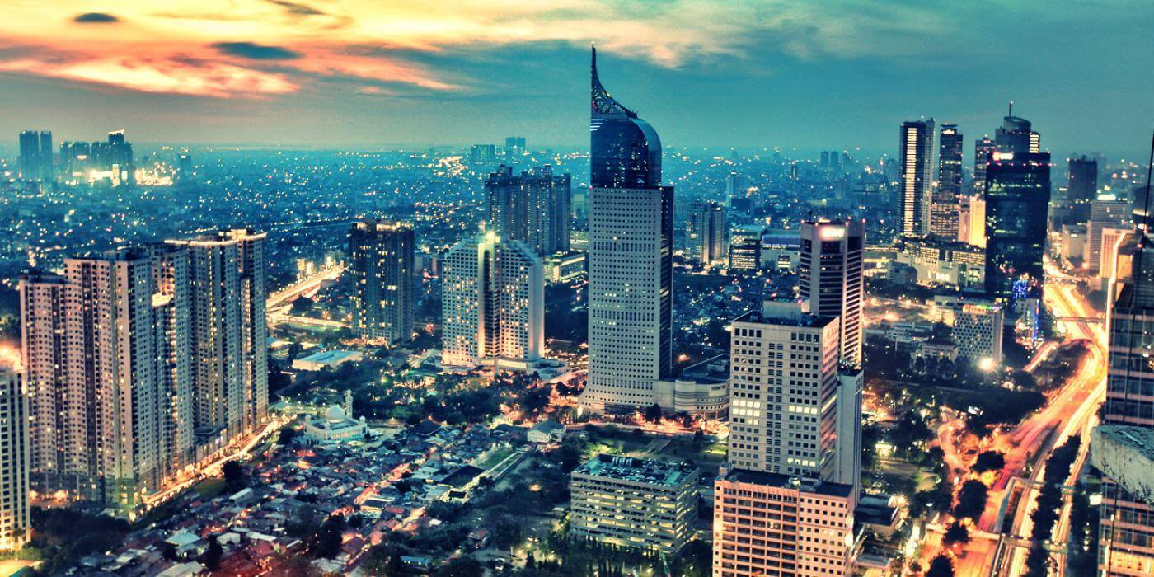

3D2N Jakarta Free & Easy (GV-2)

3天2晚 雅加达 自由行 (GV-2)

|  |  |
| --- | --- |
| **Day** | **Fun Itinerary / 行程 TOUR CODE : I-3JKT** |
| **1** | **Kuala Lumpur – Jakarta**  Upon arrival at Jakarta Airport. You will be meet up our representative and proceed to hotel check-in.  **吉隆坡 – 雅加达**  到达万隆机场后,乘空调旅游巴士送往酒店登记。 |
| **2** | **Jakarta (B)**  After breakfast, free & easy or join optional tour  **雅加达 （早餐）**  早餐后, **自由活动或参与自费项目。** |
| **3** | **Jakarta – Kuala Lumpur (B)**  After breakfast, you will be transferred to the airport for your next destination.  **雅加达 – 吉隆坡 （早餐）**  早餐后，自由活动至送往送往机场启程回国, 结束愉快旅程。 |

|  |  |  |  |  |  |  |  |  |  |
| --- | --- | --- | --- | --- | --- | --- | --- | --- | --- |
| **TRAVELING PERIOD ON 01 APR 2019 – 31 OCT 2019** | | | | | | | | | |
| **Star** | **Hotel**  **TOUR CODE : I-3JKT** | **Price per person (RM)** | | | | **Extension Night**  **(Based** **on per pax per night)(RM)** | | | |
| **Twin** | **Single** | **CWB** | **CNB** | **Twin** | **Single** | **E.Bed** | **ABF** |
| **3\*** | Arcadia by Horison or sml | 415 | 585 | 390 | 315 | 155 | 250 | 155 | 85 |
| **4\*** | Best Western Mangga Dua / Santika Premier Hayam Wuruk or sml | 490 | 705 | 455 | 280 | 185 | 310 | 185 | 105 |
| **5\*** | The Media or sml | 545 | 815 | 505 | 405 | 220 | 360 | 220 | 125 |
| **BLOCK OUT DATE : 27 MAY – 08 JUN, 01 JUL – 31 AUG 2019** | | | | | | | | | |

|  |  |
| --- | --- |
| **Optional Tour (Based on PRIVATE)** | **Nett Rates**  **(based on per person)** |
| **Half day Indo Cultural Tour** (National Museum – closed at Monday, National Monument (photostop), Sunda Kelapa, Fatahillah Square) – 6 Hours | **RM 245** |
| **Full day Jakarta Experience** (National Museum – closed at Monday, National Monument (photostop), Sunda Kelapa, Fatahillah Square, Museum Indonesia Miniature Park + Lunch) – 8 Hours | **RM 310** |
| Additional Lunch / Dinner | **RM 50** |

|  |
| --- |
| **Package Included :-** |
| * **02 Nights** hotel accommodation with daily breakfast * Round trip **Private Coach** airport & sightseeing transfer * All meals as per itinerary (non halal or vegetarian) * Sightseeing with tour guide & entrance fee as mentioned in program tour (based on **Private coach** ) |
| **Term & Conditional :-** |
| * ***Surcharge***: An additional surcharge will be imposed for the following: * **Infant (Below 24Months )** - Only pay for Tipping. |
| **Remark :-** |
| 1. Minimum 02paxs per booking. Only Valid for **Malaysia Market**.The tour is based on **Private Coach.** 2. High season and Long weekend will be surcharge (if applicable). 3. General **travel period** : **01 Apr 2019** until **31 Oct 2019** ( Travel **date must completed by 31 Oct 2019**) 4. No refund for any unused portion of this package or during tour 5. The sequence of the itinerary and meals is subject to change without notice by the local ground agency 6. Rate are based on compulsory shopping stop. 7. Any cancellation that made by clients for any unutilized services, unused tours or hotel rooms are non-refundable |