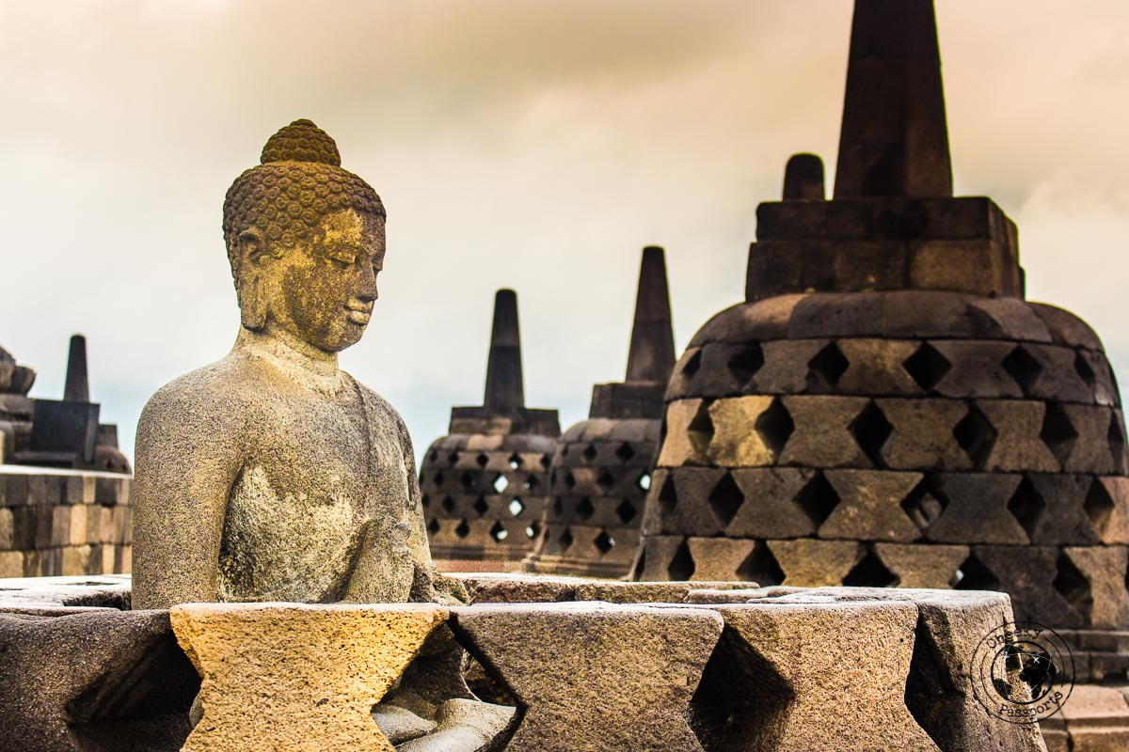

**5D4N Historical Borobudur**

**5天4晚 日惹~婆罗浮屠**

|  |  |
| --- | --- |
| **Day** | **Fun Itinerary / 行程 TOUR CODE : YOG-5BRB** |
| ***1*** | **Kuala Lumpur – Jogjakarta (L/D)**  Meet and greet with our guide at Yogyakarta airport, then continue to the oldest town called **Kotagedhe,** Kotagede as the center of silver handicrafts in Yogyakarta. Keeping around 170 old buildings built in 1700 to 1930, "Kotagede is not only named Silver City but an Old Capital City", then continue to Shopping at **Malioboro shopping center.** Lunch and Dinner at local resto, Check in hotel.  **吉隆坡 – 日惹 （午/晚餐）**  抵达日惹国际机场后,由专业导游迎接送往参观【**庫塔歌德村**】一个拥有百年历史的村尚保存传统的银器制作。 午餐后，购物于【**Malioboro街**】晚餐后送往酒店登记入住 |
| ***2*** | **Borobudur – Lava Tour (B/L/D)**  After breakfast, pick up from at your hotel and proceed to **Cangkringan –** a village in the slope of Mt Merapi that is totally destroyed after the last great eruption of Merapi in November 4th and 5th, 2010. The hot cloud (pyroclastic flow) hit this village. Including visit the **Museum Gunung Merapi** **or** **Merapi Volcano Museum** which was built by supporting cost of the Department of Energy, Mining and Natural Resources and opened at October 1st, 2009. Afterward visit **Borobudur Temple and Mendut & Pawon temples**. Back to Yogyakarta city on the way can stop buy **sweet Salak Pondoh** known as snake fruit  (Optional : 4 Wheel Jeep to Mount Merapi RM 120 per jeep , max 4 pax per jeep )  **婆罗浮屠 – Lava火山 （早/午/晚餐）**  早餐后,前往【**Cangkrigan村庄**】2010年11月4-5日把这个村庄完全摧毁。然后继续参观【**Merapi火山博物馆**】午餐后，前往【**婆罗浮屠塔**】位于印度尼西亚中爪哇日惹市西北约40公里处墨拉比火山的一个山丘上，以精美的浮雕闻名于世。继续参观【**Mendut寺**】位于向东3公里从婆罗浮屠寺和Pawan寺在返回市区的路途中，可以【**购买蛇果**】。  (Optional : 4 Wheel Jeep to Mount Merapi RM 120 per jeep , max 4 pax per jeep ) |
| ***3*** | **Kasongan / Sunset Parangtritis (B/L/D)**  After breakfast, transfer to visit **Kraton Sultan’s Palace**. We continue the tour to **Taman Sari Water** **Castle,** continue to **traditional Batik Home industry**. After Lunch, continue to **Kasongan Village** is known for the traditional clay potteries. At last sunset at **Parangtritis Beach.** Dinner at local restaurant.  **卡索根村/ 日落Parangtritis 海**  **（早/午/晚餐）**  早餐后, 游览【**苏丹宫殿**】和【**日惹水晶宫**】 ,是印尼伊斯兰教苏丹的故宫. 前往【**参观巴迪制造工厂**】午餐后，参观【**Kasongan 村**】您可看到这里有许多工匠师傅亲手做的艺术品，如：花瓶，扑满，动物形象等。接着前往【**Parangtritis 沙滩**】观赏浪漫的日落。晚餐于当地餐厅 |
| ***4*** | **Solo City Tour / Hutan Pinus / Breksi Cliff (B/L/D)**  After breakfast, transfer direct to Solo City for visiting **Mangkunegaran Palace**, **Triwindu flea market**, and shopping to the **Solo Grocery Center** know as PGS Solo, on the way back to Yogyakarta visit **Imogiri Pine Forest** (Hutan Pinus Mangunan) offers exotic beauty of hundreds of towering pine tree. This forest will become famous reddish brown color of the soil, the air is fresh, cool wind, and the sun peeking in between tree clawing the sky. Renowned for its romantic scenery, the forest became one spot of interest as a place to take pictures. Continue to **Breksi Cliff** is formed by the rock mining activity by the local people. In the hands of the local artists, the 20 meters abandoned limestone cliff mining turned into tremendous spot to enjoy art performance, and sunset.  **梭罗/** **Imogiri 森林/悬崖公园**  **（早/午/晚餐）**  早餐后，前往梭罗参观旺【**古尼嘉兰皇宫**】及【**爪哇的传统舞蹈与乐队表演**】之后短暂停留于【**Solo Grocery市场**】午餐后返回日惹，参观【**Imogiri森林】**這裡有美麗的風景和寧靜的氣氛。在美麗地種下松樹之前，這個500公頃的地區曾經是一片空地。附近的其他景點包括天然泉水和水果花園。您可邊嘗試找到最佳的拍照角度。随后续往【**Breksi悬崖公园**】主要风景是高耸的一排砾岩岩崖。这个悬崖已经是数百年前形成的，石灰岩得采矿活动将其变成了独特的悬崖景点。 |
| ***5*** | **Jogjakarta – Kuala Lumpur (B)**  After breakfast, you will be transferred to the airport for your next destination.  **日惹 – 吉隆坡 （早）**  早餐后，自由活动至送往送往机场启程回国, 结束5天愉快旅程。 |

|  |  |  |  |  |  |  |  |  |  |  |  |  |
| --- | --- | --- | --- | --- | --- | --- | --- | --- | --- | --- | --- | --- |
| **Star** | **Hotel**  **TOUR CODE : YOG-5BRB** | **VALIDITY : 01 APR 2019 – 31 OCT 2019** | | | | | | | | | | |
| **Price per adult per package (RM)** | | | | | | | **Extension Night**  **(Based** **on per pax per night)(RM)** | | | |
| **02-03** | **04-06** | **07-10** | **11-15** | **16 up** | **Single supp** | **Twin** | | **Single** | **E.Bed** | **ABF** |
| **3\*** | **Pesonna Tugu** or sml | 1695 | 1460 | 1370 | 1280 | 1275 | 480 | 150 | | 260 | 135 | 65 |
| **4\*** | **The Rich** or sml | 1770 | 1540 | 1450 | 1370 | 1355 | 560 | 170 | | 300 | 150 | 85 |
| **5\*** | **Eastparc** or sml | 1930 | 1700 | 1605 | 1530 | 1510 | 710 | 215 | | 390 | 195 | 100 |
| **5\*** | **Royal Ambarrukmo** or sml | 2040 | 1810 | 1720 | 1650 | 1630 | 825 | 240 | | 440 | 220 | 100 |
| **BLOCK OUT DATE : 19 – 21 APR, 26 MAY – 09 JUN 2019** | | | | | | | | | | | | |

|  |
| --- |
| **Package Included :-** |
| * **04 Nights** hotel accommodation with daily breakfast * Round trip **Private Coach** airport & sightseeing transfer * All meals as mentioned in itinerary (non halal or vegetarian). * Escorted orientation tour by **English Speaking Guide.** * Sightseeing with tour guide & entrance fee as mentioned in program tour (based on **Private coach** ) |

|  |
| --- |
| **Term & Conditional :-** |
| * ***Surcharge***: An additional surcharge will be imposed for the following: * **Mandarin Speaking Guide –** subjected to availability with surcharge RM100/guide/day. Tipping RM50 per person * **Child Fare :** Child Half Twin 100% ;Child with Bed 85% ; Child without bed 65% of Tour Fare. * **Infant (Below 24Months )** - Only pay for Tipping. |
| **Remark :-** |
| 1. **Compulsory Tipping RM 50.00 per person**. 2. Only Valid for **Malaysia Market**. 3. The tour is based on **Private Coach.** 4. Minimum 02paxs per booking. 5. **Mandarin speaking guide** subjected to availability with surcharge RM100/guide/day. Tipping RM50 per person 6. General **travel period** : **01 APR 2019** until **31 OCT 2019** ( Travel **date must completed by 31 OCT 2019**) 7. No refund for any unused portion of this package or during tour 8. The sequence of the itinerary and meals is subject to change without notice by the local ground agency 9. Rate are based on compulsory shopping stop. 10. Any cancellation that made by clients for any unutilized services, unused tours or hotel rooms are non-refundable |