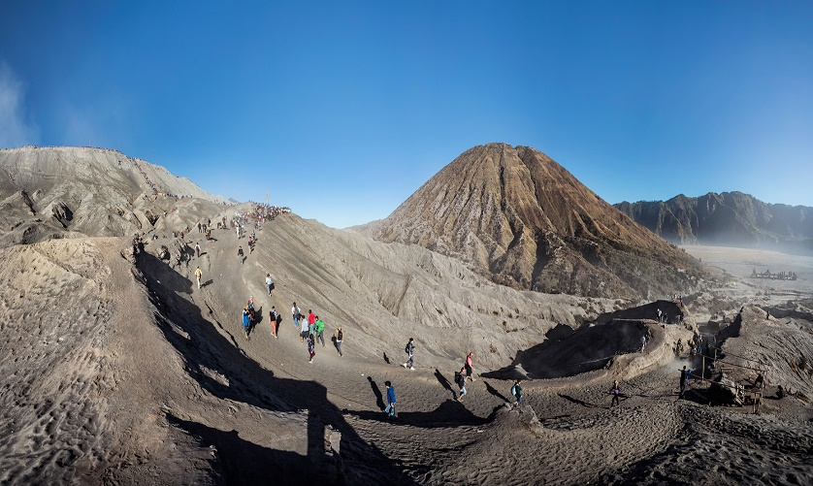

**4D3N Surabaya Full Board**

**4天3晚 泗水**

|  |  |
| --- | --- |
| **Day/天数** | **Fun Itinerary / 行程 TOUR CODE : SUB-4FB** |
| ***1*** | **Kuala Lumpur – Surabaya – Mt Bromo (L/D)**  Arrive at Surabaya International Airport. Meet & greet with our tour guide, proceed to **Cemorolawang/Tosari Village** at Bromo area & Overnight.  **Weekend surcharge at Mt. Bromo RM 50/pax (Saturday & Sunday)  **吉隆坡 – 泗水 – Bromo火山 （午/晚餐）**  抵达泗水机场后，由专业导游迎接您及前往位于**Bromo火山**的【**Cemorolawang/Tosari 村**】。过后前往入住酒店。  **周末附加费用 Mt. Bromo RM 50/pax (星期六 & 星期日) |
| ***2*** | **Sunrise Mt.Bromo - Malang (B/L/D)**  At 3.30 in the early morning you will be wake up & start **Mt. Bromo tour** using 4WD Jeep, to witness sunrise from Pananjakan view point. The tour will continue to the **crater of Mt. Bromo** crossing the sea sand. Arrive at Jeep parking area, the tour will conducted by **pony riding** (own expenses) cross sea of sand to the rim of the crater and climb up 245 stairs. After enjoy the surrounding of Mt. Bromo, back to hotel for breakfast and repacking. Next, transfer to **Malang City** & check in hotel.  **Bromo火山日出 – 马郎 （早/午/晚餐）**  清晨3:30准时出发前往**Bromo火山之旅**。首先乘坐4WD抵达集合点然后徒步抵达【**Bromo火山边缘欣赏日出**】，然后经过【**浩瀚的沙洲**】（骑小马自费）再攀爬245梯阶然后沉溺在Bromo火山的怀抱与壮丽的景色。之后，返回酒店享用早餐，收拾行李之后前往【**马朗市区**】晚餐后，送往酒店休息。 |
| ***3*** | **Batu Tour - Surabaya (B/L/D)**  Breakfast at hotel, proceed to **Batu City** (40 minutes) visit to **Jatim Park II, Batu Secret Zoo, Transportation Museum** and **Apple Plantation** (a local people farm). Then transfer back to Surabaya en route drop by **Tanggulangin** for leather home industry and **Sidoarjo** for shrimp crackers + Embroidery  **Batu之旅 - 泗水 （早/午/晚餐）**  早餐后，前往**Batu市区** （40分钟车程）参观【**Batu动物园**】和【**苹果种植园**】。之后，返回泗水。途经【**Tanggulangin皮革中心**】和【**Sidoarjo虾饼制造中心**】和【**刺绣坊**】。晚餐后，送往酒店休息。 |
| ***4*** | **Surabaya – Kuala Lumpur (B)**  After breakfast, you will be transferred to the airport for your next destination.  **泗水 – 吉隆坡 （早）**  早餐后，自由活动至送往送往机场启程回国, 结束4天愉快旅程。 |

|  |  |  |  |  |  |  |  |  |
| --- | --- | --- | --- | --- | --- | --- | --- | --- |
| **CAT** | **HOTEL**  **TOUR CODE : SUB-4FB** | **Travel Date** | **Price per Adult per package (RM)** | | | | | |
| **02 - 03** | **04 - 06** | **07 - 09** | **10 - 15** | **16 up** | **Single Supp** |
| **3\***  **2\***  **3\*** | **Surabaya :** Max One Hotel Tidar or sml  **Mt Bromo :** Nadia or sml  **Malang :** Swiss Belinn or sml | **01 APR –**  **31 OCT 2019** | **2040** | **1520** | **1430** | **1390** | **1250** | **425** |
| **3\***  **2\***  **4\*** | **Surabaya :** Swiss Belinn Tunjungan or sml  **Mt Bromo :** Lava View or sml  **Malang** : Savana or sml | **2105** | **1580** | **1490** | **1450** | **1310** | **490** |
| **4*+**  **2\***  **4\*** | **Surabaya :** Four Point by Sheraton or sml  **Mt Bromo :** Lava View or sml  **Malang** : Atria or sml | **2205** | **1685** | **1590** | **1550** | **1410** | **590** |
| **BLOCK OUT DATE : 01 – 10 JUN 2019** | | | | | | | | |

|  |
| --- |
| **Package Included :-** |
| * **03 Nights** hotel accommodation with daily breakfast * Round trip **Private Coach** airport & sightseeing transfer * All meals as mentioned in itinerary (halal or vegetarian). * Escorted orientation tour by **English Speaking Guide.** * Sightseeing with tour guide & entrance fee as mentioned in program tour (based on **Private coach** ) |

|  |
| --- |
| **Term & Conditional :-** |
| * ***Surcharge***: An additional surcharge will be imposed for the following: * **Mandarin speaking guide Fee** (subjected to availability with surcharge) : RM120 per guide per day. Tipping RM45 per person * **Child Fare :** Child Half Twin 100% ;Child with Bed 85% ; Child without bed 65% of Tour Fare. * **Infant (Below 24Months )** - Only pay for Tipping. |
| **Remark :-** |
| 1. **Compulsory Tipping RM 40 per person**. 2. Only Valid for **Malaysia Market**. 3. The tour is based on **Private Coach.** 4. Minimum 02paxs per booking. 5. **High season and Long weekend will be surcharge (if applicable).** 6. General **travel period** : **01 Apr 2019** until **31 Oct 2019**( Travel **date must completed by 31 Oct 2019**) 7. No refund for any unused portion of this package or during tour 8. The sequence of the itinerary and meals is subject to change without notice by the local ground agency 9. Rate are based on compulsory shopping stop. 10. Any cancellation that made by clients for any unutilized services, unused tours or hotel rooms are non-refundable |