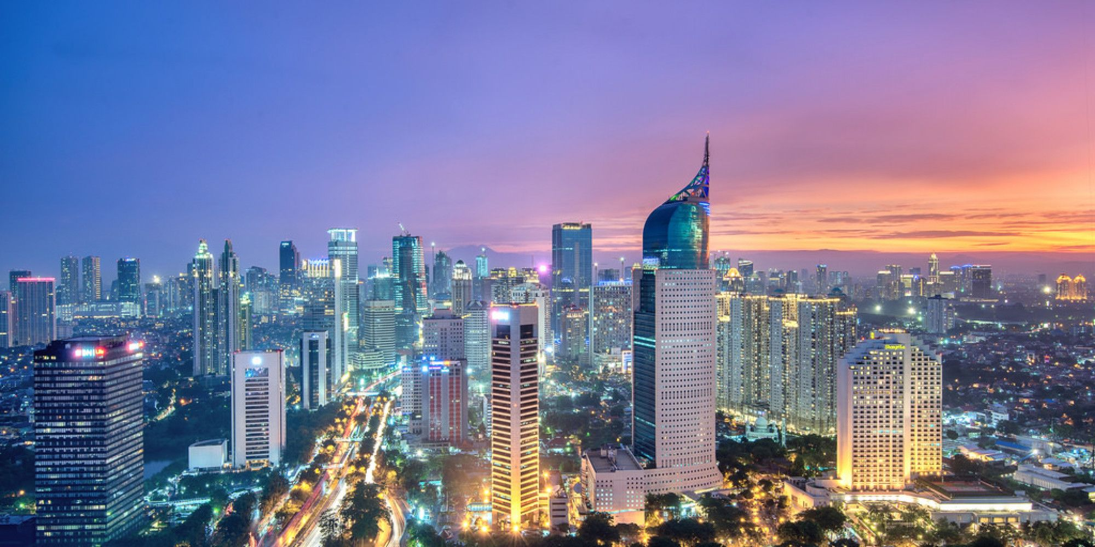

3D2N Jakarta Full Board (GV-2)

3天2晚 雅加达 (GV-2)

|  |  |
| --- | --- |
| **Day** | **Fun Itinerary / 行程 TOUR CODE : I-3JKT** |
| **1** | **Kuala Lumpur – Jakarta (D)**  Welcome to Jakarta, upon arrival at Soekarno - Hatta International Airport of Jakarta, meeting and greeting by our guide. Proceed to visit **Sunda Kelapa Old Harbour** and **Fatahillah Square** then photo stop at **National Monument**. Check in hotel for overnight. Dinner at local restaurant. Overnight at Jakarta.  **吉隆坡 – 雅加达 （晚餐）**  抵达后，由专人接机，进行雅加达城市观光。参观【**帆船码头】 ，【Fatahillah广场】，【国家独立纪念**】。晚餐在当地餐馆 |
| **2** | **Jakarta (B/L/D)**  After breakfast at hotel, proceed to visit Indonesia in **Miniature** (Taman Mini Indonesia Indah), a 160 hectare recreation park which is designed to give visitors a general overview of Indonesian culture and traditions. Afterwards, proceed for Jakarta shopping tour at **ITC Mangga Dua**. Back to hotel. Lunch and Dinner will be served at local restaurant.  **雅加达 （早/午/晚餐）**  早餐后，前往参观印尼【**迷你园】**里面包含了印尼各个地区文化的缩影。占地160公顷。然后返回雅加达市享受【**购物乐趣**】。午餐和晚餐在当地餐馆。 |
| **3** | **Jakarta – Kuala Lumpur (B)**  After breakfast, you will be transferred to the airport for your next destination.  **雅加达 – 吉隆坡 （早餐）**  早餐后，自由活动至送往送往机场启程回国, 结束愉快旅程。 |

|  |  |  |  |  |  |  |
| --- | --- | --- | --- | --- | --- | --- |
| **TRAVELING PERIOD ON 01APR 2019 – 31 OCT 2019** | | | | | | |
| **CAT** | **Hotel**  **TOUR CODE : I-3JKF** | **Price per Adult per package (RM)** | | | | |
| **02 - 03** | **04 - 06** | **07 - 15** | **16 up** | **Single Supp** |
| **3\*** | Arcadia by Horison or sml | **815** | **700** | **620** | **590** | **295** |
| **4\*** | Best Western Mangga Dua / Santika Premier Hayam Wuruk or sml | **860** | **750** | **665** | **625** | **340** |
| **5\*** | The Media or sml | **925** | **815** | **730** | **705** | **405** |
| **BLOCK OUT DATE : 27 MAY – 08 JUN, 01 JUL – 31 AUG 2019** | | | | | | |

|  |
| --- |
| **Package Included :-** |
| * **02 Nights** hotel accommodation with daily breakfast * Round trip **Private Coach** airport & sightseeing transfer * All meals as per itinerary (non halal or vegetarian) * Escorted orientation tour by **English** Speaking Guide * Sightseeing with tour guide & entrance fee as mentioned in program tour (based on **Private coach** ) |
| **Term & Conditional :-** |
| * ***Surcharge***: An additional surcharge will be imposed for the following: * **Child Fare (under 10 years) :** Child Half Twin 100% ;Child with Bed 85% ; Child without bed 65% of Tour Fare. * **Infant (Below 24Months )** - Only pay for Tipping. |
| **Remark :-** |
| 1. **Compulsory Tipping RM 30 per person**. 2. Minimum 02paxs per booking. Only Valid for **Malaysia Market**.The tour is based on **Private Coach.** 3. High season and Long weekend will be surcharge (if applicable). 4. General **travel period** : **01 Apr 2019** until **31 Oct 2019** ( Travel **date must completed by 31 Oct 2019**) 5. No refund for any unused portion of this package or during tour 6. The sequence of the itinerary and meals is subject to change without notice by the local ground agency 7. Rate are based on compulsory shopping stop. 8. Any cancellation that made by clients for any unutilized services, unused tours or hotel rooms are non-refundable |