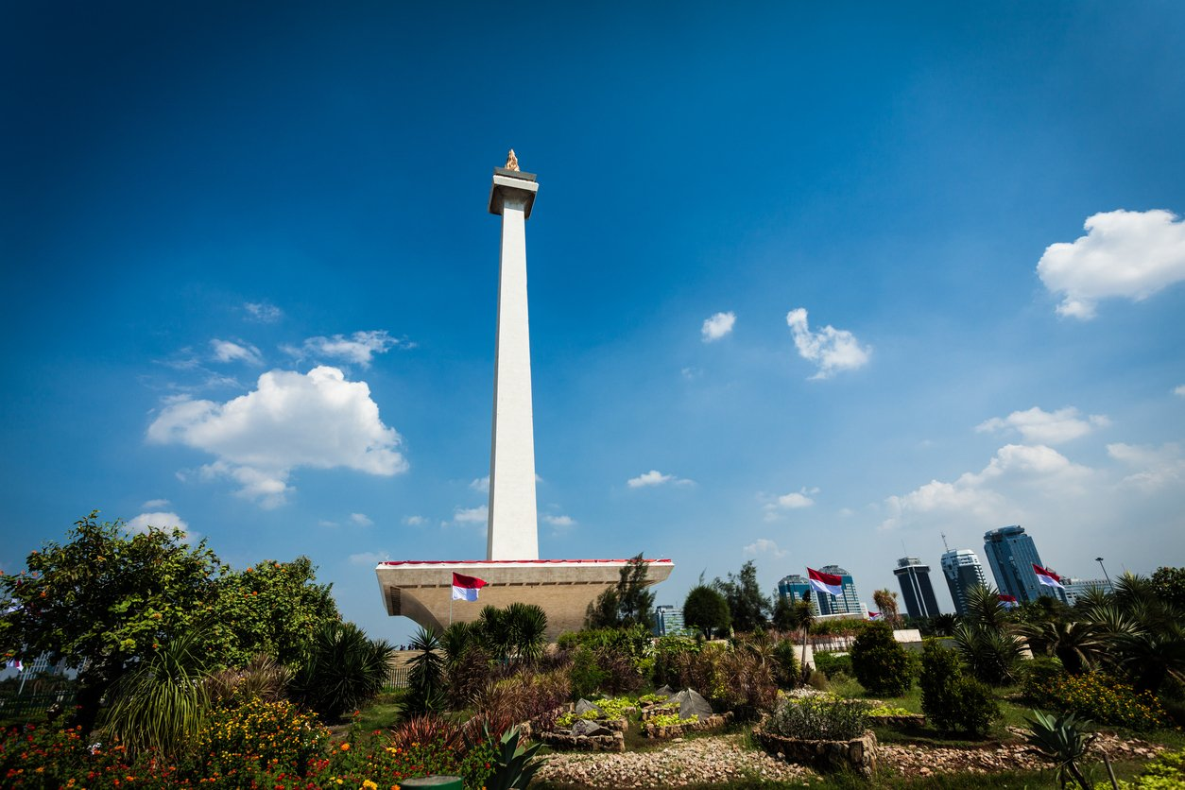

4D3N Jakarta Bandung Full Board

4天3晚 雅加达 万隆

|  |  |
| --- | --- |
| **Day /天数** | **Fun Itinerary / 行程 TOUR CODE : I-4JBD** |
| ***1*** | **Kuala Lumpur – Jakarta (D)**  Welcome to Jakarta, upon arrival at Soekarno - Hatta International Airport of Jakarta, meeting and greeting by our guide. Proceed to visit **Sunda Kelapa Old Harbour** and **Fatahillah Square** then **photo stop at** **National Monument**. Check in hotel for overnight. Dinner at local restaurant. Overnight at Jakarta.  **吉隆坡 – 雅加达 （晚餐）**  乘搭客机飞往雅加达。抵达后，由专人接机，进行雅加达城市观光。参观【**帆船码头】 ，【Fatahillah 广场】，【国家独立纪念**】。晚餐在当地餐馆。 |
| ***2*** | **Jakarta – Bandung (B/L/D)**  After breakfast at the hotel. Afterward direct transfer to Bandung, on the way will visit **Indonesia in Miniature** (Taman Mini Indonesia Indah), Lunch at local restaurant. Arrive Bandung, shopping program to some **Factory Outlets,** such as, Rumah Mode, Heritage, Summit, etc and dinner at local restaurant. Back to hotel  **雅加达 – 万隆 （早/午/晚餐）**  早餐后，使用高速公路前往万隆， 途中参观【**印尼迷你园**】。到达万隆后，继续前往【**万隆的直销工厂购物**】如：Rumah Mode, Heritage, Summit等等。晚餐后，入住万隆酒店休息。 |
| ***3*** | **Bandung (B/L/D)**  Breakfast at hotel. Proceed to **White Crater Volcano** where you can enjoy crater in Indonesia. After that transfer to **Ranca Upas Hot Spring Water** and **Ciwidey Strawberry Farm**. Lunch at Indonesian food restaurant. Afterwards back to Bandung city and transfer to **Cihampelas Jeans Street** for shopping program at Factory outlets. Dinner at local restaurant, back to hotel and free program  **万隆 （早/午/晚餐）**  早餐后, 前往观光【**白色火山湖**】。接着前往【**Ranca Upas温泉区】**享受温泉。过后前往【**草莓园**】。午餐后，继续前往【**万隆市进行购物**】。晚餐后，送往酒店休息。 |
| ***4*** | **Bandung / Jakarta – Kuala Lumpur (B)**  After breakfast, you will be transferred to the airport for your departure.  **万隆 / 雅加达– 吉隆坡 （早餐）**  早餐后，自由活动至送往送往机场启程回国, 结束4天愉快旅程。 |

|  |  |  |  |  |  |  |
| --- | --- | --- | --- | --- | --- | --- |
| **TRAVELING PERIOD ON 01 APR 2019 – 31 OCT 2019** | | | | | | |
| **CAT** | **HOTEL**  **TOUR CODE : I-4JBD** | **Price per Adult per package (RM)** | | | | |
| **02 - 03** | **04 - 06** | **07 - 15** | **16 up** | **Single Supp** |
| **3\*** | **Jakarta**: Arcadia by Horison or sml  **Bandung**: Tebu / Pasar Baru Square or sml | **2000** | **860** | **760** | **720** | **325** |
| **4\*** | **Jakarta**: Best Western Mangga Dua / Santika Premier Hayam Wuruk or sml  **Bandung**: Grand Tebu / Jayakarta or sml | **1155** | **920** | **820** | **780** | **385** |
| **5\*** | **Jakarta:** The Media or sml  **Bandung:** Papandayan / Prama Preanger or sml | **1285** | **1025** | **920** | **880** | **490** |
| **BLOCK OUT DATE : 19 – 20 APR, 27 MAY – 10 JUN, 01 JUL – 31 AUG 2019** | | | | | | |

|  |
| --- |
| **Package Included :-** |
| * **03 Nights** hotel accommodation with daily breakfast * Round trip **Private Coach** airport & sightseeing transfer * All meals as per itinerary (non halal or vegetarian) * Escorted orientation tour by **English** Speaking Guide * Sightseeing with tour guide & entrance fee as mentioned in program tour (based on **Private coach** ) |

|  |
| --- |
| **Term & Conditional :-** |
| * ***Surcharge***: An additional surcharge will be imposed for the following: * **Child Fare (under 10 years) :** Child Half Twin 100% ;Child with Bed 85% ; Child without bed 65% of Tour Fare. * **Infant (Below 24Months )** - Only pay for Tipping. |
| **Remark :-** |
| 1. **Compulsory Tipping RM 40 per person**. 2. Only Valid for **Malaysia Market**. 3. The tour is based on **Private Coach.** 4. Minimum 02paxs per booking. 5. **High season and Long weekend will be surcharge (if applicable).** 6. General **travel period : 01 Apr 2019** until **31 Oct 2019** ( Travel date must completed by **31 Oct 2019**) 7. No refund for any unused portion of this package or during tour 8. The sequence of the itinerary and meals is subject to change without notice by the local ground agency 9. Rate are based on compulsory shopping stop. 10. Any cancellation that made by clients for any unutilized services, unused tours or hotel rooms are non-refundable |