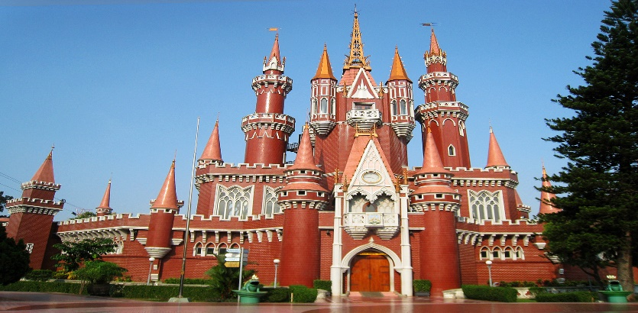

5D4N Jakarta Puncak Bandung Full Board

5天4晚 雅加达 万隆

|  |  |
| --- | --- |
| **Day** | **Fun Itinerary / 行程 TOUR CODE : I-5JBD** |
| ***1*** | **Kuala Lumpur – Jakarta (D)**  Welcome to Jakarta, upon arrival at Soekarno - Hatta International Airport of Jakarta, meeting and greeting by our guide. Visiting **Sunda Kelapa Old Harbour** and **Fatahillah Square**, **The Monument National** (photo stop) Check in hotel for overnight. Dinner at local restaurant. Overnight at Jakarta.  **吉隆坡 – 雅加达 （晚餐）**  乘搭客机飞往雅加达。抵达后，由专人接机，【**Sunda Kelapa Old Harbour帆船码头**】和【**Fatahillah Square】**，【**国家独立纪念**】（拍照）。晚餐在当地餐馆。 |
| ***2*** | **Jakarta (B/L/D)**  After breakfast at hotel, proceed to visit **Indonesia in Miniature** (Taman Mini Indonesia Indah) a 160 hectare recreation park which is designed to give visitors a general overview of Indonesian culture and traditions. Afterwards, proceed for Jakarta **shopping tour at Tanah Abang or Mangga Dua**. Back to hotel. Lunch and Dinner will be served at local restaurant. Overnight at Jakarta.  **雅加达 （早/午/晚餐）**  早餐后，前往参观【**印尼迷你园**】。里面包含了印尼各个地区文化的缩影。占地160公顷。然后返回雅加达市**享受购物乐趣**。午餐和晚餐在当地餐馆。 |
| ***3*** | **Jakarta – Bandung (B/L/D)**  Breakfast at hotel then proceed to visit **Safari Park** and **passing through Puncak tea plantation.** Afterwards, proceed to Bandung. Lunch and dinner at local restaurant. Check in hotel and overnight in Bandung.  **雅加达 – 万隆 （早/午/晚餐）**  早餐后，前往参观【**野生动物园**】和【**亚峰茶园**】。接前往万隆，午晚餐在当地餐馆，入往万隆的酒店休息。 |
| ***4*** | **Bandung (B/L/D)**  Breakfast at the hotel. Today We have fullday Bandung Tour by visiting **White Crater Volcano** and **Ranca Upas Hotspring** + **Ciwidey strawberry Farm**. Lunch at local rest. Back to Bandung we’ll **shopping at Factory Outlet** such as **Rumah Mode, Heritage, The Summit and The Kosmo**, afterwards dinner at local rest then free program.  **万隆 （早/午/晚餐）**  早餐后，前往【**白色火山湖**】后前往**【Ranca Upas温泉区**】享受温泉。过后前往【**草莓园**】。午餐后， 继续前往万隆市前往万隆的【**直销工厂购物**】，如：**Rumah Mode, Heritage, Summit, Kosmo** 等等进行购物。晚餐后，送往酒店休息。 |
| ***5*** | **Bandung / Jakarta – Kuala Lumpur (B)**  After breakfast, you will be transferred to the airport for your departure.  **万隆 / 雅加达– 吉隆坡 （早餐）**  早餐后，自由活动至送往送往机场启程回国, 结束5天愉快旅程。 |

|  |  |  |  |  |  |  |
| --- | --- | --- | --- | --- | --- | --- |
| **TRAVELING PERIOD ON 01 APR 2019 – 31 OCT 2019** | | | | | | |
| **CAT** | **HOTEL**  **TOUR CODE : I-5JBD** | **Price per Adult per package (RM)** | | | | |
| **02 - 04** | **05 - 09** | **10 - 15** | **16 up** | **Single Supp** |
| **3\*** | **Jakarta:** Arcadia by Horison or sml  **Bandung**: Tebu / Pasar Baru Square or sml | **1370** | **1125** | **970** | **950** | **375** |
| **4\*** | **Jakarta**: Best Western Mangga Dua / Santika Premier Hayam Wuruk or sml  **Bandung:** Grand Tebu / Jayakarta or sml | **1470** | **1230** | **1070** | **1060** | **485** |
| **5\*** | **Jakarta:** The Media or sml  **Bandung:** Papandayan / Prama Preanger or sml | **1600** | **1355** | **1200** | **1180** | **605** |
| **BLOCK OUT DATE : 19 - 20 APR , 27 MAY – 10 JUN , 01 JUL – 31 AUG 2019** | | | | | | |

|  |
| --- |
| **Package Included :-** |
| * **04 Nights** hotel accommodation with daily breakfast * Round trip **Private Coach** airport & sightseeing transfer * All meals as per itinerary (non halal or vegetarian) * Escorted orientation tour by **English** Speaking Guide * Sightseeing with tour guide & entrance fee as mentioned in program tour (based on **Private coach** ) |

|  |
| --- |
| **Term & Conditional :-** |
| * ***Surcharge***: An additional surcharge will be imposed for the following: * **Child Fare (under 10 years) :** Child Half Twin 100% ;Child with Bed 85% ; Child without bed 65% of Tour Fare. * **Infant (Below 24Months )** - Only pay for Tipping. |
| **Remark :-** |
| 1. **Compulsory Tipping RM 50.00 per person**. 2. Only Valid for **Malaysia Market**. 3. The tour is based on **Private Coach.** 4. Minimum 02paxs per booking. 5. General **travel period : 01 Apr 2019** until **31 Oct 2019** ( Travel date must completed by **31 Oct 2019**) 6. No refund for any unused portion of this package or during tour 7. The sequence of the itinerary and meals is subject to change without notice by the local ground agency 8. Rate are based on compulsory shopping stop. 9. Any cancellation that made by clients for any unutilized services, unused tours or hotel rooms are non-refundable |